NLR / NASA -000000





Traffic Manager User Manual v10.0.09

Jacco M. Hoekstra
Frank J.L. Bussink
Bart W.W.M. Heesbeen
Rob C.J. Ruigrok
National Aerospace Laboratory NLR, Amsterdam, The Netherlands

SUMMARY

The Traffic Manager is the key element of the Free Flight research performed at NLR and NASA LaRC for a number of projects. It is now also a standard element of the flight simulation configuration as experiment controller station and data logging tool.

This manual is not a structured overview of all commands of the Traffic Manager. It is also not meant to be complete. It is meant as a briefing guide, which will guide you through using the Traffic Manager. Therefore it is essential to use a paper version of this manual next to a PC with the Traffic Manager running. When performing all steps outlined in this guide, you will not only be able to create aircraft and generate scenarios, but you will also get a feel for the structure and rationale of the user interface. First you will create an aircraft and play around with it and record this in a scenario file. Then you will use a more complex scenario file to play with the display options. After having had the flavor of a scenario with all bells and whistles, you will learn how to create a complex scenario yourself. The last step is to control and understand the output described in the data-logging chapter.

For advanced users editing the scenario files is in fact like programming a scenario. The range of commands allows a freedom comparable to computer programming. This manual was based on the Traffic Manager version 9.1.07 but downwards compatibility has been maintained since version 1.0. Scenario files from the beginning of TMX should still run. It also means that this manual can be used for any future version of the Traffic Manager. Demo versions of the Traffic Manager do have all the features described in this manual except for the external connections. Sample scenario files are provided with the Traffic Manager and some will be discussed in the manual.

The separate reference manual contains a list of all commands, their syntax and the meaning, ordered in categories by their function. It is recommended to keep a copy of this and the reference manual at hand when using the traffic manager.

Table of Contents

1 Introduction 5
1.1 What is the Traffic Manager? 5
2 Installing the Traffic Manager 7
3 Creating and controlling Aircraft 9
3.1 Starting the Program 9
3.2 Graphical user interface 11
3.3 Creating and controlling an aircraft 12
3.4 Adding a route to an aircraft 17
4 Controlling the display 19
4.1 Loading a scenario 19
4.2 Display settings for a/c symbols & routes 20
4.3 Zooming and panning 21
4.4 Background data 22
4.5 Experiment and Clearance Area input via Map window 23
4.6 View the navigation & Traffic display of an aircraft 24
4.7 Making snapshots & movies 25
5 Scenario generation 28
5.1 Introduction 28
5.2 Before we can start 28
5.3 Dallas Forth Worth scenario 32
5.4 Hints 36
5.5 Use of macro's: How to CALL a Command-file 37
5.6 Terminal Area 38
5.7 Traffic Flow Management function 38
6 Miscellaneous features 41
6.1 Polygons and polyspaces 41
6.2 Wind fields in TMX 42
6.3 ADS-B model 43
6.4 Record & Playback 45
7 External interfaces 50
7.1 Ethernet connections 50
7.2 Command string formats 59
7.2.1 Traffic Manager direct commands to external simulator 60
7.2.2 Traffic Manager scenario control messaging commands 66
Appendix I: Example scenario files 68

Introduction

What is the Traffic Manager?
The Traffic Manager is the key element of the Free Flight research performed at NLR and NASA LaRC for a number of projects. It is now also a standard element of the flight simulation configuration as experiment controller station and data logging tool.

The traffic manager has been used as off-line traffic simulator (including fast-time simulations) and as an on-line traffic simulator, providing a realistic traffic environment for one or more flight simulator connected to the traffic manager. The simulation is completely interactive. Models react to each other and to the connected flight simulators.

The Traffic Manager is now used for a lot of functions:

- off-line traffic simulation
- on-line traffic simulation
- experiment controller station
- scenario editor
- scenario player
- scenario generator
- data logging tool
- demonstration tool
- server for internet sessions

The aircraft models in the Traffic Manager consist of:

- performance model (including fuel consumption)
- autopilot model (with all basic altitude, speed and heading modes as well as the FMS coupled LNAV (lateral) and VNAV (vertical & speed) modes)
- ASAS system (conflict detection & resolution system selectable from 10 variants or none)
- A Flight Management System (FMS) with route following capability and time meeting capability
- Pilot model with parameters for reaction time, scheduling effects and recovery maneuvers
- ADS-B models simulating sampling effect of ADS-B receivers

Every aircraft is calculated with a certain update rate, which is higher if the aircraft is nearby and visible in the out-of-the-window view of a connected flight simulator. This ensures smooth movements when banking or pitching.

Apart for this aircraft simulation loop, the Traffic Manager is event driven. Its central element is a so-called command stack. Every module in the Traffic Manager is controlled by one or more commands. Commands can be edited by the user in the command window (the blue console window in the lower part of the screen). But there are also other sources of commands. Commands can be read from a recorded or edited scenario file. Commands can be received over the Ethernet connection from any other module in the simulation configuration. Commands are also used by some modules to control other modules in the Traffic Manager or elsewhere in the simulation configuration. Since these commands allow complete control over the Traffic Manager, it has a flexibility that is extremely useful in a research environment.

The Traffic Manager is a program that was originally designed in 1996 on a 486 PC to study the behavior of more than one aircraft during Free Flight with airborne separation assurance. For this a traffic simulation program was written with a graphical user interface. This program should also be capable of simulating a traffic environment for the flight simulator experiments at NLR. Consequently, the aircraft models needed to be more than simple moving blips. Therefore six-degrees-of-freedom aircraft models that pitched and banked in a realistic way were implemented, using Eurocontrol’s BADA database as a reference for the performance parameters of over 200 aircraft types. A goal was to simulate a high number of aircraft since high traffic densities were considered to be the most critical cases for Free Flight. For this reason the Traffic Manager has been programmed in a way to optimize for CPU performance. The models are robust enough to handle lower update rates due to the computational demands of high-density traffic. Even though the program is now running on very powerful PCs and ported to the Windows platform, it is still optimized for execution speed allowing simulating scenarios with more than 1000 aircraft simultaneously flying.

Installing the Traffic Manager
The Traffic Manager is distributed on a CD, as a Zip-file (extension .zip) or a self-extractor (extension .exe). When using the self-extractor, you will be asked to specify a directory name where the program should be installed. This can be any directory for instance. “C:\Program Files\Traffic Manager”. It will then extract and create several subdirectories named Input, Output and Data.

The zip files can be extracted in a similar way, using WinZipTM. Make sure the subdirectories are created (WinzipTM options ‘Use Folder Names’ should be on) by checking the target directory. There should at least be an Input, Data and Output directory. If not, delete the files and extract by double clicking on the zip file and make sure the ‘Use Folder Names’ option is on.

When copying the Traffic Manager from a CD ROM, make sure that after you copy the files you make the folder ‘write-able’ by right-clicking the master folder and selecting ‘properties’. De-select the Read-Only button and apply to all sub-folders.

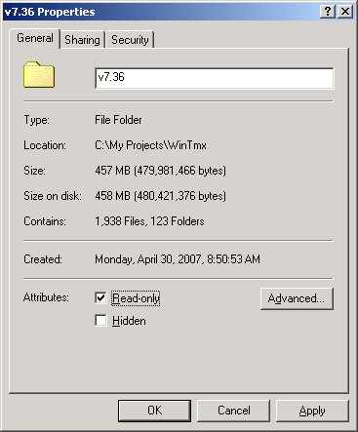

The main program is located in the main Traffic Manager directory. It is the File called WinTmx.exe (or if the extensions are not visible: the file named WinTMX of type Application). Dragging it to the Desktop with the mouse will create a convenient ShortCut to start the Traffic Manager.

The Traffic Manager uses the Microsoft DirectXTM drivers for drawing and Internet connections. DirectX version 7 or higher is required. DirectX can be downloaded from the Microsoft Site at: http://www.microsoft.com/directx

Creating and controlling Aircraft

Starting the Program
Double click on the Shortcut you created on your Desktop or on the WinTmx.exe file in the Traffic Manager folder. The screen will be black and a pop-up window labeled ‘Information’ will appear. This window quickly lists the files that are read and contains a text indicating the version of the Traffic Manager that you’re using for instance “Traffic Manager v10.0.09”.

After a short while a File Open dialog box appears labeled ‘Select Input Scenario file name (or CANCEL for None)”. Press the Escape key (‘Esc’) since we’re not loading a scenario file yet.

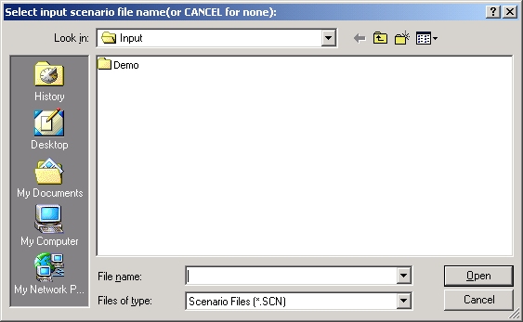

Then another very similar File Open dialog box appears now labeled “Select file name for scenario recording (or Cancel for None)”. Enter a filename here for instance ‘MyTry1’ It will then either ask you to create it (which is OK) or to overwrite it if the file already exists (if you choose No you can enter another name like MyTry2 etc.)

Now the screen will show the GUI of the Traffic Manager as shown in figure 3.1.

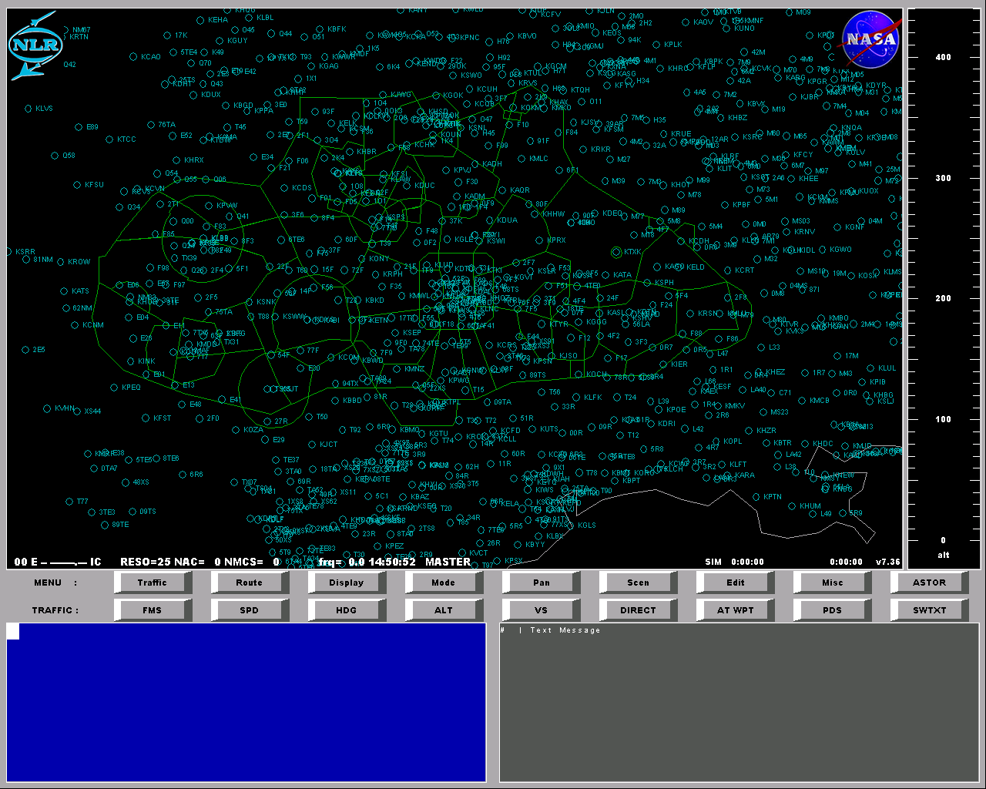

figure 3.1 Traffic Manager Graphical User Interface
When you would like to quit using the Traffic Manager, type ‘QUIT’ and press Enter. Or press the Escape key (This will insert ‘QUIT’) and then press enter. (Equivalent commands like Exit, Bye, or System will also work as quit). Else continue with reading trying the commands described in this chapter.

Graphical user interface
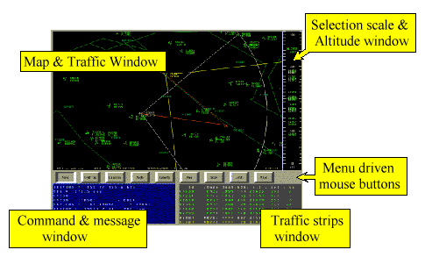
figure 3.2 The elements of the graphical user interface
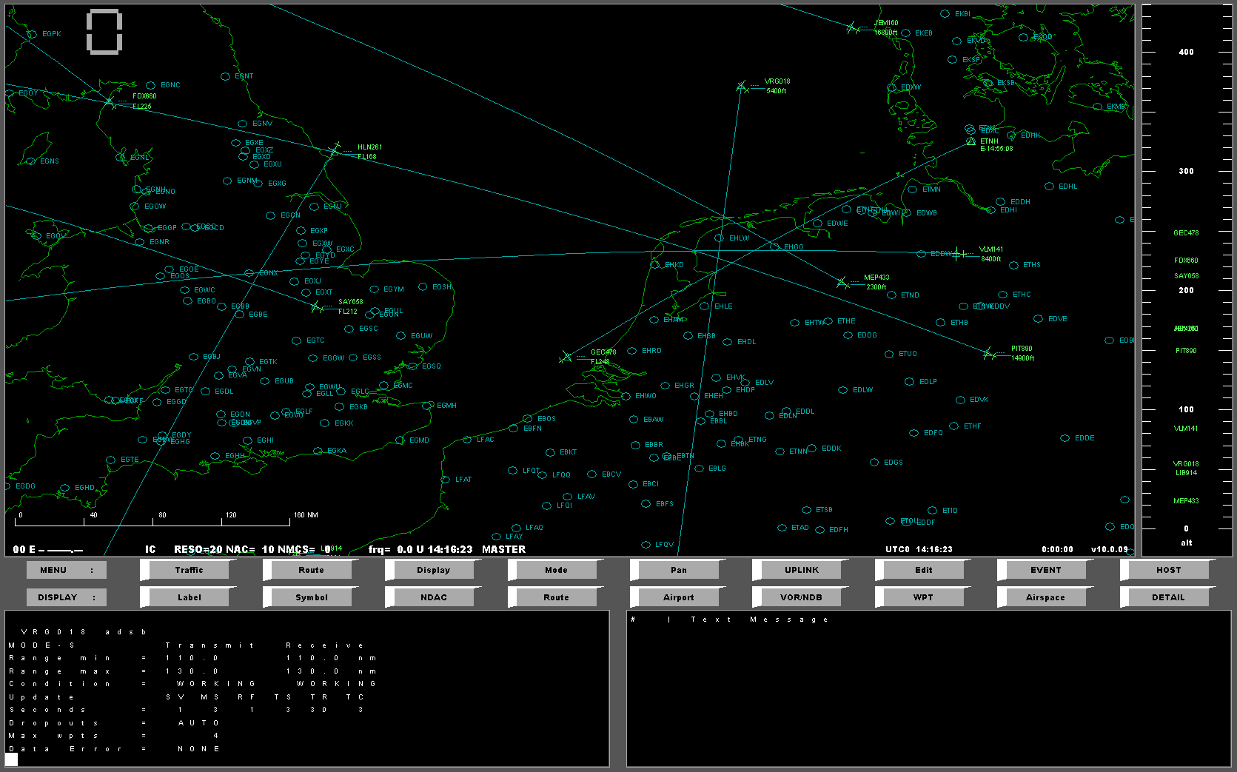
Selection scale & Altitude window
Menu driven mouse buttons
Map & Traffic window
Command & Message window
Traffic strips window
figure 3.3 The elements of the graphical user interface

The most important parts of the user interface are the map/traffic/radar window and the command window.
The command window is a console. Here the user types commands that control the simulation. The program will also show error messages and status information in this window.
The strip window, which is optional (described later when the file scr_cfg.dat is explained), shows several aircraft parameters in table form. It shows the values of the aircraft controlled by external flight simulators and some selected by the user.
The map or radar window shows a certain area with the traffic and a lot of other graphical information. The map window allows not just output but is also an important input device. By clicking on the window, aircraft can be selected, lat/lon coordinates can be entered, routes can be edited etc. etc.
Some other values can be selected using the selection bar next to the window. When appropriate (based on the contents of the current command line) it will show speeds, altitudes or aircraft types.
The mouse selectable buttons can be considered as shortcuts or macros for commands that can also be typed into the command window. These buttons contain a menu structure. The main menu consists of the first row of buttons. Clicking one of these buttons will show the items of the submenu listed in the second row. The most left non-clickable item in the second row states the name of the active submenu. The menu structure, labels and commands of the buttons are determined by a data file (‘buttons.dat’ in the Data subfolder) that can be edited by the user. You can explore this by opening the file with Notepad.

Creating and controlling an aircraft
To create an aircraft we use the CRE command. Type CRE and then press Enter. The command window will now show:
CRE id, type, lat*, lon*, hdg*, alt, ias/mach
This shows the sequence of the following in-line arguments:

id = aircraft id, the call sign of the new aircraft
type = aircraft type, ICAO four letter code for aircraft type, e.g. B747
lat = latitude of position where aircraft should be created in decimal degrees
lon = longitude of position where aircraft should be created in decimal degrees
hdg = heading of aircraft (by default true unless in ‘magnetic mode’, see later)
alt = altitude, either in ft (“25000”) or flight levels (“FL250”)
ias/mach = indicated airspeed in kts (if>1.0) or Mach (if <1.0)

Example of the CRE-command:
CRE KL204,B74F,52.4,4.0,270T,FL250,310
The T behind the heading of 270 ensures it will be entered as a true heading even though the heading reference mode is magnetic. This is not the most practical way to create an aircraft. Especially entering latitude/longitude positions this way is tedious.
A more intuitive way to create an aircraft is using the mouse. By clicking on the ‘Edit’ menu button, it will list the buttons of this submenu in the second row. This menu contains a button labeled ‘CRE’. Click on this button. The command window now shows the CRE command help text and “CRE *,” the line below. A bar next to the map window shows a list of aircraft types. Click on F100 (a Fokker 100). In the command window “F100,” is added to the command line. Then click on the map window where you want to create the aircraft. A yellow aircraft symbol appears. Click on a position placed in the direction where you want the aircraft to fly. The aircraft symbol rotates to the heading. The command line now shows a lat/lon position and a heading. Next to map window a bar with an altitude scale appears. Click on 250 to enter FL250. Then a Speed scale will appear. Click on the speed 300 and the speed will be added to the command line and Enter will be pressed. The aircraft received a random name (due to the * behind the CRE command) and is now flying in the specified direction. This aircraft has been created without touching the keyboard!
The stars in the CRE help text mean: this value can be entered by clicking in the map window.
The aircraft we’ve created is still not flying. This is because we did not start the simulation in the Traffic Manager yet. It is still in Initial Condition mode (IC). The map window shows the simulation mode in the bottom left corner. Also the simulation time in the right bottom corner is still at zero. Click on the button labeled ‘Mode’. Now a row of buttons appears to control the simulation mode. Click on OP. The time starts running and the aircraft starts moving. It does not matter whether you create aircraft when you’re still in IC (initial condition) or whether you’re already in operate (=running). Commands will work independent of simulation mode.
To speed things up, increase the real-time factor (rtf) by using the RTF command. To make it for instance triple speed, enter:
RTF 3
The aircraft will now move at three times the speed. Enter RTF 1 to return to real time mode again. (You can check the current value by just entering RTF.). You can also use the fast forward command FF. By entering FF, the simulation will go as fast as the computer can do. Both the RTF and FF command can be followed by a time string (hh:mm:ss or sssss). When using the time string with the FF command, the simulation will go to the HOLD mode after elapsing the given time. When using it with the RTF command, the simulation will, after the time has elapsed, return to RTF 1. When you use the time string format hh:mm:ss, then the simulation will return to the above states at the given time, however if you use sssss, the simulation will elapse the specified number of seconds before returning to the above state.
FF 2:34
If this command returns the error message: “No FF allowed when MasterHost/MultiHost/ATC/WEB on”, make sure the flags MasterHost ,MultiHost and swatc are set to False in the file config.dat.
The aircraft now approaches the border of the map view. You can zoom out a few times by entering a number of minus signs (without spaces in between) on the command line and press enter. Or, better let’s move the map window. This can be done by entering PAN LEFT or PAN UP or by clicking one of the buttons in the Pan submenu in the button row. The Pan submenu also contains zoom commands. This submenu allows resizing the map window while typing a command and entering lat/lons with mouse clicks. The mouse can also be used to PAN, just right-click on the position where you want to PAN to.
Let’s try to control the aircraft. For example purposes we assume the callsign of the aircraft to be KL204. We can now select an altitude on the autopilot by entering the following command:
ALT KL204,FL210
Which is equivalent with:
KL204 ALT FL210
Normally the command is the first word on the command line, but when the first argument is an aircraft id, it can also be used before the command. Commas and spaces are both valid delimiters. Commas allow skipping an optional argument (indicated by [ ] brackets in the help text.).
Again this can also be done with the mouse. Click on the aircraft first, then on the ALT button in the Traffic Submenu and then on a value in the selection bar next to the map window.
To verify that the KL204 is descending, double click on the aircraft and you will see the vertical speed indicating a descent. Just entering the call sign has the same effect. It is translated to a so-called POS command (that nobody uses since you can double click on the aircraft with the same effect).
If you want to control the vertical speed, enter it behind the altitude in feet per minute:
KL204 ALT FL270 1000
In much the same way, you can control the heading of the aircraft enter a heading or click in the direction):
KL204 HDG 253
Remember that to avoid typing the call sign, you can single click on the aircraft to enter the call sign on the new command line first!
Or using a relative heading as in “Turn left 17 degrees”:
KL204 LEFT 17
The aircraft will now turn towards the designated heading. Speed can be controlled by the SPD command. It is entered in Indicated Airspeed in kts or as a Mach number (any value lower than 1.0).
We can see the navigation/traffic display of our aircraft by entering:
ND KL204
(or NAVDISP instead of ND). We see there is no traffic around the aircraft. Enter RADAR or press the Tab key (nav disp / map window toggle) to change back to the map window. Let’s add some traffic in a simple way (more about scenario generation with routes later), the ‘multiple create’ command or MCRE. Type “ MCRE ? ” to see the help text. This will show the following line:
MCRE n, type/*, alt/*, spd/*, dest/*
The arguments of this command can be replaced by wildcards if you don’t want to specify its value (except for the number of aircraft n). All aircraft will be created in the currently visible area in the map window. Enter the following command:
MCRE 10,*,*,*,*
This will create 10 aircraft of any type, at any altitude, with any speed and any destination. In the Edit submenu, there is a button named MCRE10, which will enter this command. Clicking it a few times quickly fills the screen with traffic. Press Tab again to return to the navigation display of KL204. It should show a more interesting picture now. In the navigation display, just as on the map window lat/lons and aircraft can be selected by clicking on the display (only the horizontal navigation display).
Now quit the Traffic Manager by pressing the Esc-key and then enter or type ‘QUIT’ and then enter.
Let’s see what we’ve recorded in the MyTry.scn scenario file. Open the file (in the Input subdirectory) with Notepad. It should something like this:

figure 3.4 Scenario file Mytry.scn created in this session
0:00:00.00>CRE AN074 , FK10, 52.49248, 0.83671, 73.8T FL250, 300
0:01:29.07>alt an074,fl210
0:02:30.16>an074 alt fl270 1000
0:02:44.00>an074 hdg 253
0:04:32.96>AN074 left 17
0:04:52.46>CRE HD807 ,FK50, 52.36897, 6.03302,358.2T, 5800, 239
0:04:52.46>DEST *,ENZV
0:04:52.46>CRE VM080 ,EA34, 50.08668, 4.23705,137.8T, 6100, 244
0:04:52.46>DEST *,LFSB
0:04:52.46>CRE SQ491 ,AT42, 54.55793, 8.93849,236.7T, 16400, 212
0:04:52.46>DEST *,LFRC
0:04:52.46>CRE KU610 ,AT42, 50.82255, 10.31771,319.8T, 8000, 330
0:04:52.46>DEST *,BIKF
0:04:52.46>CRE TE864 ,EA31, 53.20224, 2.92087,156.3T, 3300, 287
0:04:52.46>DEST *,LFKS
0:04:52.46>CRE CX909 ,B737, 52.01645, 5.00086,164.2T, 8500, 267
0:04:52.46>DEST *,LFKJ
0:04:52.46>CRE AI583 ,EA31, 53.37935, 3.64880, 43.0T, 4300, 294
0:04:52.46>DEST *,EFPO
0:04:52.46>CRE SU929 ,BA46, 55.58760, 3.91063,183.1T, 2500, 223
0:04:52.46>DEST *,LFLC
0:04:52.46>CRE DM244 ,FK70, 51.60601, -1.41087,130.4T, 21800, 281
0:04:52.46>DEST *,LIRP
0:04:52.46>CRE SA780 ,B767, 52.37748, -3.91739,121.2T, 13500, 237
0:04:52.46>DEST *,LFSM

As can be seen it is a time-labeled recording of commands. The first fields are reserved for the simulation time in the HH:MM:SS.hh format (hh=two decimals of the seconds), followed by a prompt ‘>’.
This is a recording of what we’ve typed with a few differences:
- The pan & zoom commands have not been recorded (this would annoy anyone playing back this scenario)
- The Start command (‘OP’) and RTF command has not been recorded for the same reason. (Simulation control commands are not recorded)
- Our NAVDISP command has not been recorded either.
- There is no “MCRE 10 , * , * , * , * ” command in the recorded file. Instead it contains the list of CRE commands caused by the MCRE command. This ensures repeatability every time this scenario is run. MCRE 10, * , * , * , * uses the randomizer and would result in a different scenario every time you run the scenario file.
It does contain our altitude and heading commands, since this affects the Traffic pattern. Any command that influenced the traffic behavior is recorded.
In the scenario file, one line can contain more than one command when separated by a semicolon (‘ ; ’). This is also true when typing in the command window. Several buttons use this. For instance in the buttons.dat file, it is specified that the CRE button generates the following command:
CRE ? ; INSEDIT CRE*,
This results in showing the help text of the CRE command followed by a line where ‘CRE *,’ is already typed in. The online command line interpreter recognizes the need for an aircraft type and will show these in the selection bar next to the map window. If you want to add something to the scenario file, play it again and also switch recording on by entering a (different!) name in the second File dialog box. It will record both the commands you enter as well as the ones read from the file. The Traffic Manager won’t know the difference. The result is that you can edit a scenario in a cumulative way.

Adding a route to an aircraft
Apart from heading and altitude commands it is also possible to specify a route for an aircraft, including a destination, altitude & speed restrictions, etc. The FMS function in the aircraft will automatically follow the route and control the autopilot of the aircraft model.

Restart the traffic manager. Do not select any scenario files. (Press ESC twice) and create an aircraft as described in the beginning of this chapter. How do we specify a route for this aircraft? The easiest case is the direct routing scenario. Just specify a destination by entering an airport with the DEST command. Click in the display to select the aircraft. Type ‘DEST’, now click on an airport in the display. The aircraft now has a destination. As a result the aircraft will try to navigate to this destination in an optimal way: it will try to climb to its preferred cruise level and then descend in time to do a continuous descent to the airport. Normally (with the taxi-switch off) the aircraft will be deleted during approach at 1500 ft.

In a lot of scenarios there will be aircraft, which will only fly direct for a part of the flight or not at all. For instance ground-controlled aircraft will in general follow an airway consisting of waypoints. To enter a route into the flight management system of the aircraft, the ADDWPT command can be used:

ADDWPT acid, (wpname/lat,lon) , [wpalt] , [wpspd], [RTA], [(wphtyp, tubeh, tubew)], afterwp

ADDWPT acid, wpname ; adds a waypoint with a specified published name
ADDWPT acid, lat, lon ; adds a waypoint specified by lat/lon position
ADDWPT acid, wpname, alt , spd ; adds a waypoint with altitude and speed restriction
ADDWPT acid, wpname, afterwp ; inserts a waypoint

Arguments:
acid call sign of aircraft
wpname name of a beacon or fix
lat/lon a lat/lon position instead of a name
wpalt altitude to be reached at the waypoint [optional]
wpspd speed (IAS kts/Mach) to be reached at the waypoint [optional]
RTA required time of arrival constraint [optional]
wphtyp waypoint horizontal type [optional]
tubeh,tubew tube height and width [optional]
afterwp waypoint after which this waypoint should be inserted, by default it will be added at the end of the route [optional]
As always, the aircraft id (acid or call sign) can be used before the command. The last three arguments are optional, so valid examples of this command are:

KL204 ADDWPT KL204,SPY
Adds SPY to the route as last waypoint before destination

KL204 ADDWPT KL204, 51.0,3.0
Adds a lat/lon position (use mouse) and will give it a generic name (KL204001)

KL204 ADDWPT NICKY,FL100,280
Adds NICKY to the route with an altitude and speed constraint

KL204 ADDWPT SPL, , ,SPY
Inserts SPL after SPY in the route of KL204.

For bookkeeping an origin can also be defined using the ORIG command:

KL204 ORIG EHAM

When double clicking on the aircraft we will now see the KL204 is a B74F flying from EHAM to EBBR (or whatever you specified). To see the complete route use the LISTRTE command:

LISTRTE KL204

When the route is longer than one window press enter until you’ve seen the complete list of waypoints with altitude and speed constraints (shown as ‘-1’ if none).

You can use DELWPT to delete waypoints. Read the next chapter on how to show VORs, NDBs and waypoints on screen to facilitate the editing of the routes.

Controlling the display

Loading a scenario
Double click on the Shortcut you created on your Desktop or on the WinTmx.exe file in the Traffic Manager program folder. The file reading message box appears.

After a short while a File Open dialog box appears labeled ‘Select Input Scenario file name (or Cancel for None)”. Select the scenario file ‘AL25T.SCN’ from the WinTMX/Scenarios/Miscellaneous subfolder.

Then the Recording File Open dialog box appears. Press ESC since we don’t want to record a file this time.

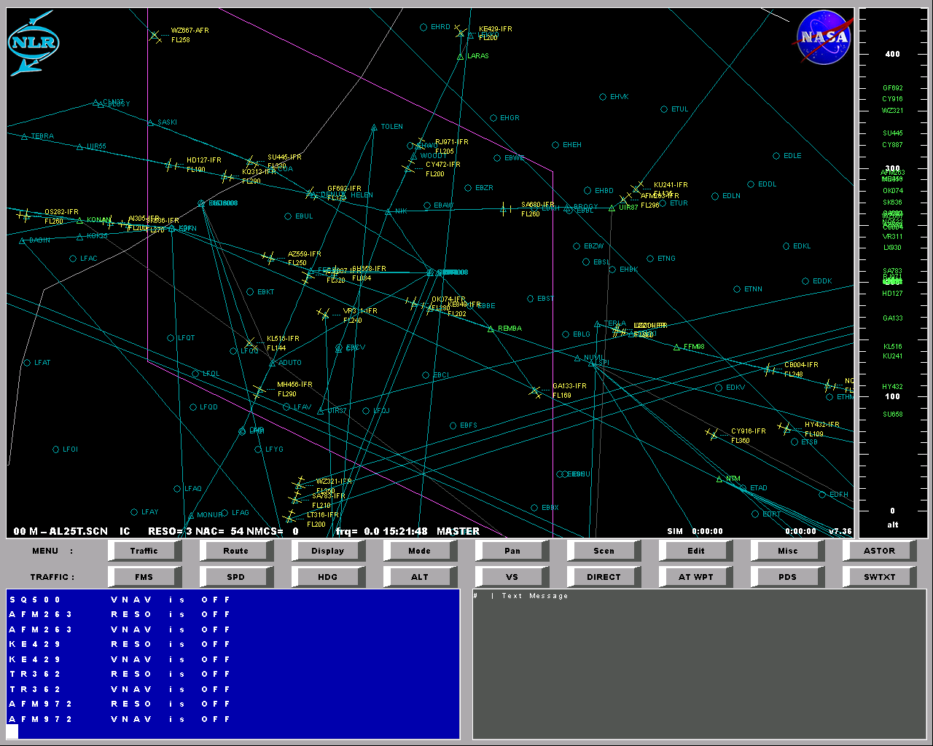
The GUI appears with a lot of aircraft and blue and magenta lines. The screen looks like figure above. Most scenario files will do a better job setting up the screen for you, but as it is, AL25T leaves most of it up to the user. This is great for the purpose of this chapter. So let’s see what we can do about this hopelessly cluttered screen. Scenario generation will be covered by the next chapter, this chapter just uses this complex scenario to demonstrate the display features.

Display settings for a/c symbols & routes
Press the ‘OP’ button or enter the command ‘op’ (operate) to start the scenario. The first step is to change the aircraft symbols. This can be done with the ‘SYMBOL’ command that can also be found in the ‘Display’ submenu under the Symbol button. The symbol command does not take any arguments. It cycles through a sequence of aircraft symbols:

- little aircraft (default)
- arrowheads (similar to CDTI)
- arrowheads with protected zone (can overlap)
- arrowheads with half the protected zone (should not overlap)

Enter the symbol command once to see the arrowhead symbol. (I like this symbol more than the default aircraft symbol). Press F8, which will walk through the command history, once to recall the last command line: ‘SYMBOL’ and press enter to switch to the next aircraft symbol. You will see huge arrowheads with circles around them indicating the protected zone. (Ok, so the circles look more like octagons). The circles have a radius of 5 nautical miles (unless the protected zone size has been changed in the ‘conflict.dat’ data file). Because the radius is equal to the horizontal separation minimum, these zones may overlap, but an aircraft should not be inside the zone. This is hard to spot on the map display. Therefore enter ‘SYMBOL’ again (or hit the button) to switch to the next symbol: circles with half the radius of the protected zone. Now a loss of separation is indicated by two overlapping circles, at least when the aircraft are at about the same altitude (vertical separation less than 1000 ft). In this case the aircraft symbols will be red to indicate the loss of separation. Enter ‘Symbol’ another two times to end up with the little arrowheads. These symbols do hardly clutter the display.

The screen shows mainly yellow aircraft symbols, which means that the aircraft are not fully FMS (LNAV,VNAV and SNAV) coupled. Green aircraft are fully FMS coupled autonomous (equipped with ASAS) aircraft. A controller on the ground controls blue aircraft.

To couple the FMS type in:

FMS * ON

This specific scenario has a high number of unequipped aircraft (at least 75%) throughout the run.

The amount of data that is shown in the labels can be controlled in much the same way using the ‘LABEL’ command. This will show 0,1,2 or more lines of data in the label next to the aircraft symbol.

The contents of the label are:
- call sign
- altitude (and ^ or v sign to indicate climbing or descending)
- IAS/Mach
- Type – Heading

Example of a label:
KL204
FL250^
320/0.78
B74F-331

If the aircraft is ground controlled and requests a new altitude, the requested altitude will be shown in the label. The aircraft symbol and label will be magenta when the aircraft requests an altitude.

What about all these blue lines? These are the routes as entered by the scenario file. As soon as the user enters a waypoint in a route with the ‘ADDWPT’ command the route of that aircraft appears on screen. The program does not know whether the command came from file or the user so all routes as entered by the file are shown. Newer scenario files have an extra command recorded to avoid this, but this old file does not have this so we have to switch this off ourselves. This is easily using the ‘ROUTE’ command:

ROUTE acid / *, ON/OFF

This command can switch displaying the route on or off per aircraft (using the call sign) or for all aircraft (using the asterisk). So to switch all routes off, enter:

ROUTE *,OFF

Now the blue lines disappear.

Zooming and panning
We’re still stuck with the magenta lines and the grey lines (barely visible in the upper right corner). First zoom out once using the zoom commands:

- = zoom out once
--- = zoom out three times
+ = zoom in once
++ = zoom in twice etc.

The PAN submenu also contains zoom buttons, which are helpful when typing a command and entering aircraft, airports or lat/lons by clicking on the map display.

Entering any number of plus (or equivalent ‘=’ sign) or minus signs will zoom in and out. Every step will half or double the area shown (so height and width vary with a factor of about 1.4). Zoom twice to have the screen shown in the next figure.

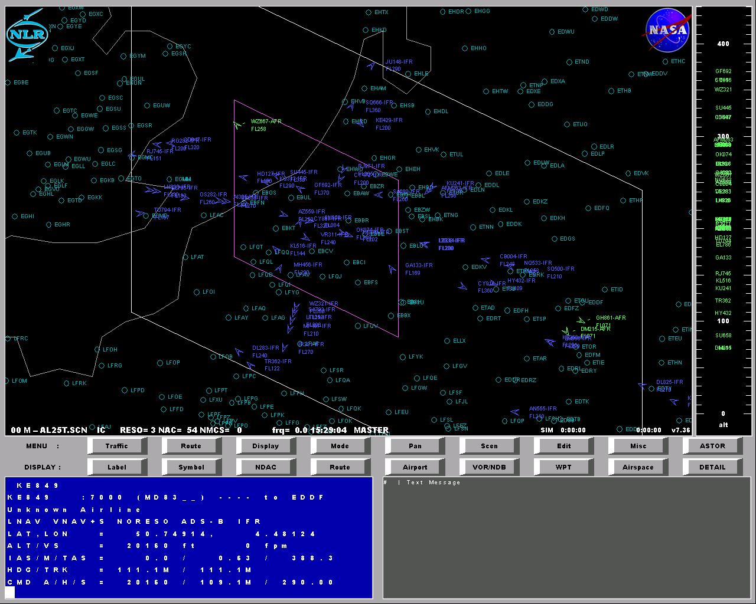
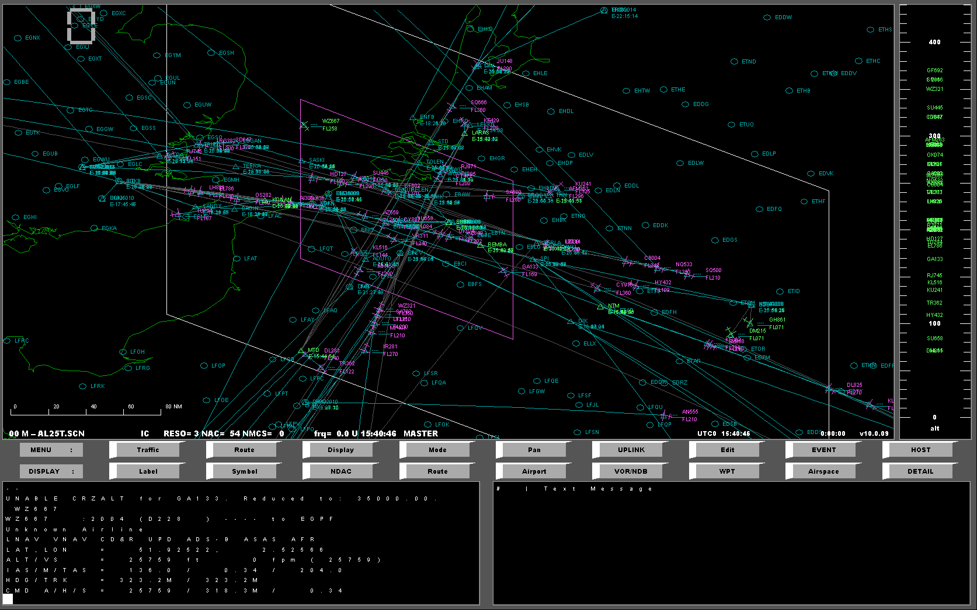
This is much less cluttered than the screen we started with.

To move the area you’re viewing, use the PAN-command. PAN can be used to move the centre of the display. It has a number of possible arguments:

- LEFT, UP, DOWN and RIGHT
- airport identifiers: EHAM, KDFW (if in the US)
- aircraft call signs
- lat/lons (click on the map display)

In the Pan-submenu, buttons are available to move up/down/left/right while entering command line arguments like aircraft, airports or lat/lons. Again, you can also use the right mouse button to pan.

Background data
The background data, which is drawn, can also be tailored to meet your specific needs. Go to the Display submenu. Now a row of buttons appears to switch display features on or off. Each switch toggles between on or off. These features include:

- Label (to control label information)
- Symbol (to change the aircraft symbol)
- NDAC to control what aircraft to display on the navigation screen (ADS-B and/or TCAS)
- Route (to turn on/off routes)
- airports (by default on)
- beacons (VOR/NDB)
- waypoints (five character identifiers)
- airspace boundaries high (default on) and low (if data available in nav database)
- geographical data detail (coastlines and/or state boundaries) (by default on)

In scenario files the command ‘DISPLAY’ (or SWRAD in older versions) can be used with any of the arguments: APT, GEO, VOR, NDB, WPT, GRID, AIRSPACE HIGH (or ASH) or AIRSPACE LOW (or ASL). This is what is under the buttons in the Display submenu. The buttons.dat file controls these buttons. You can create your own macros, which are stored under the buttons by editing this file with a simple text editor like Notepad.

If the default nav database (worldnav) does not have airspace boundaries, restart the scenario with the DFWDEMO scenario by entering:

IC DFWDEMO

The IC (Initial Condition) command restarts TMX but now with a different scenario: DFWDEMO.SCN. This scenario contains the command:

PAN KDFW

This command moves to Dallas Fort Worth (KDFW). The navigation database does include airspace boundaries and geographical data. Play around with switching the display features on or off as you wish by clicking on the buttons in the Display submenu. Returning to the default view point is performed with the following command:

PAN EBBR

To declutter the display it is also possible to select only a certain altitude range to be displayed. Try entering:

UPPALT FL250
LOWALT 2000

Now only traffic between 2000 ft and 25000 ft will be shown on the map display.

Experiment and Clearance Area input via Map window
Restart the traffic manager with the previous scenario by entering ‘IC AL25T’. Start the scenario (‘OP’ or start button), enter ‘SYMBOL’ once and zoom out twice ( - - ). We can still see a magenta and white parallelogram. These indicate two areas important for the scenario generation (see next chapter). These areas are entered by clicking on the map display.

The area within the white trapezoid indicates the so-called experiment area. This can de seen as an area of interest to the user. Aircraft that are not departing from an airport in the area, start somewhere in flight outside the experiment area (see later how this is performed automatically in the Scenario Generation chapter). Aircraft leaving this area are automatically deleted unless the use specified not to do so by using the SWDELAC command (see reference manual). This frees up space in the traffic buffer for new aircraft. Also some datalogging commands (like “ TRACK *, dt, lowalt ”) use the experiment area to ensure repeatable runs and datalogging. The experiment area is defined by entering the command ‘AREA’ followed by two (rectangle) or three (parallelogram) clicks. In case of two clicks the minimum and maximum of both latitude and longitude are used to define the area. This means any two diagonally opposing corners can be clicked. For entering three points start with the top left corner, then the top right and then the lower right corner. Experiment with the AREA command to get a feel for how to define it by clicking two or three times in the map display. Type:

AREA (do not press enter!)

And then click in the map display two or three times before pressing enter. Try it a few times and it will become clear what I mean with how to enter the parallelogram shaped area. You can also create a polygon by using the POLY commands and convert the polygon to an experiment area with the EXP command.

EXP mypolygon

The magenta area, the area where aircraft will request for altitude clearance can be entered in a similar way with the CLRAREA command. Within this area aircraft will request an altitude clearance. This can be handled by issuing a clearance with the ‘CLR’ command:

CLR acid, alt

So when for instance a climbing aircraft with call sign KL204 turns magenta and shows a REQ FL150 in the label text, the aircraft can simply be cleared up to FL190 with the command:

KL204 CLR FL190

Whether aircraft will request an altitude or not also depends on the ATM procedure. How to control ATM procedures and use these areas will be explained in the scenario generation chapter.

View the navigation & Traffic display of an aircraft
As seen in the previous chapter, there is the possibility to view the traffic on the navigation display of one of the aircraft. This a different view than the map view in several respects:

- it clips out traffic not within altitude range
- it is oriented heading up
- it provides a vertical view on the profile display
- it show a more detailed conflict symbology
- it provides insight in resolution advisories and autopilot commanded values

To see the display of one of the aircraft use the NAVDISP or ND command:

ND KL204

This will show the navigation display of the KL204 as well as a speed tape and vertical speed indicator. Autopilot commanded values are indicated by blue, resolution advisories in magenta or green.

To zoom in or out on the horizontal display use the normal zoom commands:

++ zooms in twice using standard range sequence
- - zooms out twice using standard range sequence

For the vertical display or profile, add a prefix V to zoom in and out in the vertical direction. So use the commands:

V+++ to zoom in three times and
V - - to zoom out two times

Clicking within the horizontal navigation display will work just as in the map window. You can select the nav display of another aircraft simply by entering “ND ” and then click on another aircraft symbol. You can also select the ownship in the center and type HDG and then click on the heading scale to command a heading.

To return to the overall ‘radar’ view, enter the command:

RADAR or use ‘TAB’-key to switch between map display and nav display

Using the TAB key is the easiest way to switch between map display and nav display.

Making snapshots & movies
To make a snapshot of the screen enter the following command:

GRAB example1.bmp

You can leave out the .bmp extension, because the traffic manager will add it for you. The result of this command is a file named xample1.bmp in the Output subdirectory. The BMP format is a native Windows format that is read by most Office and paint programs. So you can use this in for example MS-Word without a problem.

To create a movie or animated gif you can use the MOVIE command. MOVIE will create a sequence of snapshots of a part of the map display with a regular interval. Because the filenames will be numbered, you can use any animation program to compile this into one animation. (like Animation Shop provided with Paint Shop Pro, or the Shareware GIFcreator).

How is this done? First of all it requires some planning. Play the scenario you want to record and note down start time and end-time of the sequence you wan to record. Suppose it lasts for 6 minutes (use the simulation time in right hand lower corner of the map display). Normally you will probably want to speed it up to show a pattern. Suppose we want to compress this in a sequence of 30 seconds. Assume we want a frequency of two pictures per second in the final animation. This means we need 60 snapshots in total. Because the part of the scenario we want to record lasts 6 minutes, this means 10 snapshots per minute or one snapshot every 6 seconds of (simulated) time. To do this we enter the following command:

MOVIE START, filename, lat0, lon0, lat1, lon1, dt

In our example:

MOVIE START, hello, <click in map display twice to define box> , 6

The positions (lat0,lon0) and (lat1,lon1) should be two opposing corners of the area you want to record. Enter these positions by clicking in the map window with the mouse. The last argument dt is the sample time in seconds, which was 6 in our example. Because this time relates to the simulated time, we can use fast-time simulation when recording by for instance setting the real time factor to 3 (“ RTF 3 ”). Don’t make it too fast or the screen will not be updated between your samples! Default update time of the map window is once per second (setting in RAD_CFG.DAT data file).

The resulting files will be stored in the Output subdirectory and named:

hello001.bmp
hello002.bmp
hello003.bmp
….
hello060.bmp

Because of these ordered names, you can select all of them at once in this order when entering the source filenames in your animation creation program. Then simply click Save As and you can save it as an animated GIF. In the 97 and earlier versions of PowerPoint, you can not run an animated GIF, so you need to convert it to the AVI format before using it in PowerPoint. AVI files quickly become huge, so keep the number of samples in your animation limited to a maximum of about 100 pictures.

There are some limitations of the snapshot and movie function. One limitations is that the movie snapshot are only supported for the map window and not for the navigation display yet. (though you might experiment with it in this mode, there is a undocumented way around this)

Scenario generation

Introduction
In this chapter we will generate a scenario that can be used in an experiment. We will master the art of generating a realistic route environment, saving scenario files and editing them. Also a lot of features that will be encountered will be explained in this section. After reading this chapter one should be pretty confident with the features of the Traffic Manager.

Before we can start
The scenario generation will be explained based on the generation of the Dallas Forth Worth scenario for NASA Langley’s Peer Review in December 2000.

To make the aircraft behave realistic in a Free Flight or Route environment and to meet experiment demands several requirements are set for the scenario definition. Before we can start to generate a scenario, we need to know a few things (requirements):

- Traffic density
- Experiment area
- CD&R rules

Regarding traffic density, this is often a difficult matter. Therefore, what we normally do is to take an ATC tape of current, real-life traffic and convert this data so that the TMX can “read” it. What we need from the ATC tape here is the latitude, longitude and altitude. We can transform this data to the following CRE format (e.g. ECACBEL.SCN):

Time >CRE ID type latitude longitud hdg altitude spd
0:00:01.00>CRE AAL42 b747 50.55224 0.729593 180 6118.679 350

The aircraft ID, type, heading and speed are not relevant to measure the traffic density, so we take HDG 180 and SPEED 350 for all aircraft for example. Aircraft IDs have to be unique by the way. After loading this “scenario” in the TMX, we can measure the traffic density with the “dens” command, see section reference manual.

The experiment area needs to have a location and size. The location is free to choose, the size is highly depending on the flight time of interest in the experiment. If we are interested for example in 20 minutes of flight, the experiment area needs to be 320 nm in the direction of the flight.

This size is calculated as follows (roughly):

Aircraft fly with maximum 600 kts ground speed. 20 minutes of flight means 200 nm distance travelled with 600 kts ground speed. ADS-B look-ahead range is 120 nm for example, so the experiment area needs to be 200 + 120 nm = 320 nm in size in the direction of the flight. If there is no specific aircraft of interest in the scenario, the size can be chosen based on the area of interest, e.g. 300 nm around DFW.

The CD&R rules need to be defined before generating the scenario since the CD&R tools are active during the generation of the scenario.

Once we have defined the scenario characteristics, we define a “template” for the scenario, like DFW1.SCN:

#
# DFW1 experiment template
#

# Miscellaneous settings:

0:00:00.00>navdb usa
0:00:00.00>eth cmd off
0:00:00.00>eth atc off
0:00:00.00>area 39,-105,39,-89,27,-89,on
0:00:00.00>clrarea 39,-105,39,-89,27,-89,on
0:00:00.00>noise off
0:00:00.00>echo on
0:00:00.00>rtf 1.0
0:00:00.00>fixdt on
0:00:00.00>autostop off
0:00:00.00>pan kdfw
0:00:00.00>--

# Data logging: during generation off !

0:00:00.00>datalog off
# 0:00:00.00>track * 5 10000

# General Free Flight settings

0:00:00.00>dtlook 300;symbol;dtnolook 2;resonr 3
0:00:00.00>predasas on;manual
0:00:00.00>filter on
0:00:00.00>hdgref magnetic
0:00:00.00>clearance reject
0:00:00.00>dtreact 30
0:00:00.00>atm flgen
0:00:00.00>fflevel FL100
0:00:00.00>dfflevel 2000
0:00:00.00>dtlokatc -600
0:00:00.00>route * on

# Specific settings for scenario:
# Scenario 1: FL

# 0:00:00.00>atm flgen
# 0:00:00.00>fflevel fl100
# 0:00:00.00>dfflevel 2000
# 0:00:00.00>dtlokatc -600

# Scenario 2: Prot Airw

# 0:00:00.00>atm pa
# 0:00:00.00>fflevel 1000
# 0:00:00.00>dfflevel 1000
# 0:00:00.00>fflevel -1000
# 0:00:00.00>dfflevel -1000
# 0:00:00.00>dtlokatc -600

# Scenario 3: Full Mix

# 0:00:00.00>atm fm
# 0:00:00.00>fflevel 1000
# 0:00:00.00>dfflevel 1000
# 0:00:00.00>fflevel -1000
# 0:00:00.00>dfflevel -1000
# 0:00:00.00>dtlokatc 600

# Scenario off: default LNAV, VNAV, ASAS, RESO on

# 0:00:00.00>atm off
# 0:00:00.00>fflevel 1000
# 0:00:00.00>dfflevel 1000
# 0:00:00.00>fflevel -1000
# 0:00:00.00>dfflevel -1000
# 0:00:00.00>dtlokatc 600

The template is used to pre-set the scenario characteristics for generation of the scenario. The items will be explained below in detail.

# Miscellaneous settings:

0:00:00.00>navdb usa
0:00:00.00>eth cmd off
0:00:00.00>eth atc off
0:00:00.00>area 39,-105,39,-89,27,-89,on
0:00:00.00>clrarea 39,-105,39,-89,27,-89,on
0:00:00.00>noise off
0:00:00.00>echo on
0:00:00.00>rtf 1.0
0:00:00.00>fixdt on
0:00:00.00>autostop off
0:00:00.00>pan kdfw
0:00:00.00>--

The miscellaneous settings define:
- the navigation database to be used (USA in this case),
- connections with external simulations (OFF in this case),
- the experiment area (ON in this case with the square defined by 3 corners: lat1 = 39, lon1 = -105, lat2 = 39, lon2 = -89, lat3 = 27, lon3 = -89),
- the Clearance area (ON in this case and identical to the experiment area),
- noise on the altitude (OFF in this case),
- echo (all commands echoed to the command window, ON in this case),
- real-time factor (1 in this case),
- fixdt (ON in this case, so fast-time generation possible, as fast as the computer can do),
- autostop (defines when to stop the scenario generation, based on the data in the AUTOSTOP.DAT file, OFF in this case). The number of aircraft in the scenario have to “build up”. With this facility one can specify when to stop generation based on the “build up” rate.
- pan shows where to center the screen (KDFW in this case)
- - - (initial zoom)

# Data logging: during generation off !

0:00:00.00>datalog off
# 0:00:00.00>track * 5 10000

Datalogging is obviously OFF during scenario generation.

# General Free Flight settings

0:00:00.00>dtlook 300;symbol;dtnolook 2;resonr 3
0:00:00.00>predasas on;manual
0:00:00.00>filter on
0:00:00.00>hdgref magnetic
0:00:00.00>clearance reject
0:00:00.00>dtreact 30
0:00:00.00>atm flgen
0:00:00.00>fflevel FL100
0:00:00.00>dfflevel 2000
0:00:00.00>dtlokatc -600
0:00:00.00>route * on

The general Free Flight settings determine:
- the CD&R to be used (RESONR 3 this case, with look-ahead time 300 seconds, time between conflict detection probes of 2 seconds and symbol to define the aircraft symbol)
- predictive ASAS (ON in this case)
- filter (ON in this case )
- reference heading is magnetic
- reject all clearance requests
- reaction time of pilot models before reacting to CD&R alerts
- ATM concept (this will be explained in detail below)
- route (shows routes of aircraft, ON in this case)

The ATM concepts are defined by the ATM command. 3 different ATM concepts are defined, but these are very tailored to past experiments and need modification to be used more generic. A future version of the TMX will have improved facilities for this. The list below shows the options with different ATM concepts:

# Specific settings for scenario:
# Scenario 1: FL

# 0:00:00.00>atm flgen
# 0:00:00.00>fflevel fl100
# 0:00:00.00>dfflevel 2000
# 0:00:00.00>dtlokatc -600

# Scenario 2: Prot Airw

# 0:00:00.00>atm pa
# 0:00:00.00>fflevel 1000
# 0:00:00.00>dfflevel 1000
# 0:00:00.00>fflevel -1000
# 0:00:00.00>dfflevel -1000
# 0:00:00.00>dtlokatc -600

# Scenario 3: Full Mix

# 0:00:00.00>atm fm
# 0:00:00.00>fflevel 1000
# 0:00:00.00>dfflevel 1000
# 0:00:00.00>fflevel -1000
# 0:00:00.00>dfflevel -1000
# 0:00:00.00>dtlokatc 600

# Scenario off: default LNAV, VNAV, ASAS, RESO on

# 0:00:00.00>atm off
# 0:00:00.00>fflevel 1000
# 0:00:00.00>dfflevel 1000
# 0:00:00.00>fflevel -1000
# 0:00:00.00>dfflevel -1000
# 0:00:00.00>dtlokatc 600

In general, the ATM concepts define what aircraft modes are active and when aircraft will resolve conflicts and when not. In more technical terms, LNAV, VNAV, SNAV and RESO commands are defined, depending on the experiment area as well. These commands are different in the generation phase, the airborne phase and the ground phase. Therefore, XXgen, XXair and XXgrnd exist, where XX can be FL (flight level), PA (protected airways) and FM (full mix). The following table summarizes the ATM concepts.

Concept | LNAV | VNAV | RESO
FLAIR | ON | OFF | ON (above FFlevel)  OFF (below FFlevel)
FLGRND | ON | OFF | ON (above FFlevel)  OFF (below FFlevel)
FLGEN | ON | ON | OFF
PAAIR | ON | OFF | ON (equipped aircraft)  OFF (non-equipped aircraft)
PAGRND | ON | OFF | ON (equipped aircraft)  OFF (non-equipped aircraft)
PAGEN | ON | ON | ON (equipped aircraft)  OFF (non-equipped aircraft)
FMAIR | ON | OFF | ON (equipped airborne CD&R, unequipped ATC CD&R)
FMGRND | ON | OFF | ON (equipped airborne CD&R, unequipped ATC CD&R)
FMGEN | ON | ON | ON (equipped airborne CD&R, unequipped ATC CD&R)

Dallas Forth Worth scenario
For the DFW demo, we defined that the aircraft fly on their route, deviate from the route according their CD&R (option 3), and then turn back to their route after some time. The area was defined by latitude longitudes as shown in the previous paragraph and the traffic density was not defined but followed from the scenario.

To do automatic generation of scenarios, we have to write a so-called "autoscen" file. In the autoscen file, see DFW1GEN.ASC, you first define the number of generation airports or "sources". You can use airport identifiers for this. Then for each "source", you can specify:

autoap = Airport ID
swfx10 = Switch FK28 aircraft (generated aircraft will be of type FK28 only)
eqpfrac = Equipage fraction
eqptot = Equipage total

So: 0 % equiped: frac = 0, tot = 1
75 % equiped: frac = 3, tot = 4

Then you can specify the number of runways:

nautorw = number of runways per airport

If nautorw = 1, the aircrafts are randomly generated on altitude "autoalt" with lower limit autoalt-autoaltd and autoalt+autoaltd (see below).

If nautorw > 1, the aircraft are cyclic generated on autoalt, with 2000 ft separation

Further you can specify take-off interval (autoint), take-off interval delta (autointd), take-off altitude (autoalt, FL), take-off interval delta (autoaltd), take-off speed (autospd), take-off speed delta (autospdd), take-off heading (autohdg), take-off heading delta (autohdgd).

Next you can specify whether the destination is automatically selected.

If autodest = F, the aircraft will continue on the initial heading. If autodest = T, you can define a list of airports to which the aircraft can fly, using airport ID’s again, see below.

The funny thing is that you can specify sources at FL310 for example, so you do not always have to start on the ground with the aircraft. Moreover, if you specify an experiment area, this process can continue virtually for ever, since aircraft are deleted outside the experiment area.

# This file contains the automatic scenario definitions

nautoap = 9 ;Number of auto airports

####################### ORIGIN ###############################

autoap = 'KDFW' ;Airport
autopos = ' ' ;Begin position
swfx10 = F ;Switch FX10 special aircraft
eqplvl0 = 0 [%] ;Equippage level-0: not equiped
eqplvl1 = 0 [%] ;Equippage level-1: ADS-B out
eqplvl2 = 0 [%] ;Equippage level-2: ADS-B in/out
eqplvl3 = 100 [%] ;Equippage level-3: ADS-B in/out + ASAS
eqplvl4 = 0 [%] ;Equippage level-3: ADS-B in/out + ASAS + ITP

# Number of runways:
# nautorw = 1 => random generated altitudes with autoaltd
# nautorw > 1 => cyclic generated altitudes with 2000 ft separation

nautorw = 2 ;Number of runways at airport

# Takeoff/start data: interval, altitude, speed, heading

autoint = 120.0 [s] ;Takeoff interval (per runway)
autointd = 40.0 [s] ;Takeoff interval delta (per runway)
autoscl = 0.0 [s] ;Takeoff/start scaling factor(15300 is equivalent to 1)
autooset = 0.0 [s] ;Takeoff/start offset/delay in creating aircraft
autostop = 23400.0 [s] ;Takeoff/start stop creating aircraft
autoalt = 50.0 [FL] ;Takeoff altitude (lower minimum if cyclic)
autoaltd = 40.0 [FL] ;Takeoff altitude delta
automspd = F ;Takeoff/start manual speed (otherwise use procspd)
autospd = 220.0 [kts] ;Takeoff speed
autospdd = 40.0 [kts] ;Takeoff speed delta
autohdg = 240 [deg] ;Takeoff heading (not used at low)
autohdgd = 20.0 [kts] ;Takeoff heading delta (not used at low)

# Destination:

autodest = T ;Automatic destination (otherwise continu on hdg)
ndestlst = 8
destlst = 'KATL'
destlst = 'KEUF'
destlst = 'KGJT'
destlst = 'KDMN'
destlst = 'KBFF'
destlst = 'KANW'
destlst = 'KCID'
destlst = 'KHRL'

etc. for airport number 2 to 9 !

Next you can define routes between "citypairs" with the file [filename].RTE, where filename has to be the same as the [finename].ASC, see for example file name DFW1GEN.RTE:

# This file contains the routes for the automatic scenario definitions

nrte = 40 ;Number of auto routes

####################### ROUTE ###############################

rteid = 'KDFWKATL' ;Route
nwpts = 7 ;Number of waypoints

# Waypoints

wptid = 'GGG'
wptid = 'EIC'
wptid = 'ELD'
wptid = 'MON'
wptid = 'GLH'
wptid = 'IGB'
wptid = 'GAD'

etc. for route number 2 to 40 !

Origin and destination from the .ASC file are taken together as e.g. 'KDFWKATL' to search for this route in the .RTE file. If no routes are listed, the aircraft will fly direct, but only if "autodest = T". If "autodest = F", the aircraft will simply continue on their original heading, according autohdg / autohdgd.

Especially entering the routes for each citypair is manual work, so the more airports, the more handwork! With 8 airports around KDFW, you already need to specify about 40 routes, manually.

To see it working:

First make sure we have loaded the correct Navigation Database, type in the TMX:

NAVDB WORLDNAV

When you select as input for TMX the scenario DFW1.SCN (the “template” with settings), and you type in the TMX:

AUTOSCEN DFW1GEN

you can see the process. Just put it in Operate !

What will hapen is that the scenario will "build up". It appears that the first aircraft are "on the other side" after about 2 hours of simulated time (by the way: generation takes place in FAST TIME). When the number of aircraft is stable, you just have to type the command:

REC [filename].SCN

and let it continue to run ! The REC command saves the initial condition for the actual scenario and all following actions are recorded in this file as well. By letting it run for another hour or so, we end up with the file [filename].SCN in which we start with a stable number of aircraft which is continuously "fed" during 1 hour. After that 1 hour, the scenario will "run dry".

Graphically:

Generation Resulting scenario

Autoscen REC End
Command Command

As soon as you have a logged scenario (via the REC command), you have to include the template (DFW1.SCN) at the beginning of the [filename].SCN file, see the DFWDEMO.SCN (template is until "# Generated code follows:"). Now you can change some of the “template” settings, e.g. fixdt OFF, datalogging ON, etc. You can also use the CALL command to include a pre-defined header.

This way the DFWDEMO.SCN was created. It contains around 300 aircraft, all with routes, between 9 city pairs, with 40 routes in between. All aircraft fly LNAV, VNAV and all aircraft are ASAS equipped and RESOlve conflicts.

To run this scenario, simply select DFWDEMO when starting the TMX.

A tip to speed up TMX during generation and running the demo:

ROUTE * OFF

For each aircraft the route is displayed every cycle of the TMX, which slows down the TMX considerably.

If you want to make a snapshot of a certain situation, which you later want to use as a new initial condition, you can use the ‘SAVEIC’ command.

SAVEIC [filename].SCN

The ‘SAVEIC’ command will save the current situation to a .SCN file so you can use it again.

Hints
To define pure over flights, use the "high altitude airport" for this, and just define an
"airport" outside the experiment area and a destination "airport" just outside the
opposite side. Autoalt could be e.g. FL310 for the "source", and the aircraft will be deleted when passing the experiment area. If VNAV is ON, the aircraft might start to climb or descend after generation, depending on the distance to destination and aircraft type.

To randomize routes between the same city pairs, one has to trick TMX at this moment, since this feature is not included yet. Normally, depending on aircraft type, cruise altitude, etc. routes today or in Free Flight might be different. Currently, each citypair has 2 routes: A to B and B to A. If you need more routes, we need to adjust the TMX for that. There is one "trick" to solve it: copy e.g. KATL in the navigation database to e.g. K@TL, add K@TL to the .ASC file and add routes 'K@TL....'. This way you have a "second" Atlanta airport, with possibility to have 2 additional routes. This is not a very good solution, but at least it provides the possibility. TMX code will be changed in the future to simply add to the .RTE file more routes between the same city pair.

At each airport in the .ASC file you can "set" all the variables like autoalt, autodest, etc. By putting the same airport twice in the .ASC file with different values for the variables, you can for example create departing aircraft from KDFW and aircraft on high altitude above KDFW at the same time.

Similarly, to have more aircraft fly from KDFW to KATL than from KDFW to KCID for example, simply put KATL twice or more in the “autodest” list.

To have the same scenario running for days, simply add the IC command after the last command in the scenario file.

Use of macro's: How to CALL a Command-file
You can use the call command to call externally defined macros. Macro's are files containing a list of commands just as you would type them in the console window of TMX. This is especially useful to bundle initialization actions and avoid a lot of identical headers. This also avoids changing a lot of scenario files with an editor, if you want to change the initialization. In this way you can create your own toolset for display control, navigation databases, custom waypoint, ASAS set-up, scenario generation, etc., etc.

Here's how it works:

CALL filename

For the filename you can use any name. Default macro files are files with a .CSS extension in the input directory, but also the standard scenario file extension .SCN can be used. If no extension is provided, it will assume .SCN. So:

CALL SETUP_DFW

Will look for a SETUP_DFW.SCN file in the input directory. However, any file with any extension can be used. The syntax for a command file is simple: A list of commands. So it is just like the SCN file but without the time label and '>' sign:

PAN KDFW
ZOOM IN;ZOOM IN;ZOOM IN
PAN LEFT
OP
etc. etc.

If you copy lines from a scenario file, you can leave the time labels in.

It is possible to call a new macro from within a macro, but be aware that you can create endless loops like this by recursively calling the same macro(s). This will result in a command stack overflow and lead to unpredictable results of partially executing a stream of commands repeatedly.
Command files can be located in subdirectories. Always specify the location relative from the input directory. Do not use the './', this is not necessary as paths will be combined. Valid filenames are:

setdisplay (will use 'setdisplay.scn' unless not found then it will look for 'setdisplay') setdisplay.cmd (will first look for 'setdisplay.cmd.scn' and then find 'setdisplay.cmd' wallh.scn
larc/setup_dfw (looks for file in the subdirectory named 'larc')
../macros/larc/setup_dfw (will go up one dir and then look in macros/larc for setup.dfw.scn)

Use this function to combine commands for an ATM procedure, resolution method or display set-up for a lot of scenarios.

Terminal Area
The scenarios use the TMA definition. If an airport has more runways, the aircraft are generated on the edge of the TMA, defined as in TMA.DAT. The TMA definition uses quadrants in which aircraft are generated. There are 4 departure quadrants and 4 arrival quadrants. Arriving aircraft aim at the nearest arrival quadrant; departing aircraft are generated in the quadrant closest to their destination airport.

Traffic Flow Management function
The Traffic Flow Management (TFM) function implemented in TMX enables the scheduling of planned flights stored in the so-called Flight Queue. To build a TFM scenario the Flight Queue must be populated with planned flights using the CREFLIGHT command. The minimum arguments for the CREFLIGHT command are:
- Flight ID
- Aircraft type
- Origin airport
- Destination airport
Optional arguments are:
- Departure time (at gate) [sec] UTC
- Aircraft mass [kg]
- Cruize altitude [ft]
- Cruize speed [IAS or Mach]
If optional arguments are not provided they will be derived from standard data or generated randomly. The departure time will be a random number between 10 minutes from now and 2 hours later. Aircraft mass will be estimated using total flight distance. Cruize altitude will be estimated using aircraft mass. Cruize speed will be set to default cruize speed for the selected aircraft type specified in BADA.
An example of a scenario that creates a number of flights in the Flight Queue is TFM_test101.scn (see Appendix I). It creates 50 flights between 7 airports and forces all flights to depart at 01:00 (= 3600 sec). This is the planned departure time at the gate. To derive the time at the departure fix at the edge of the TMA a standard time is defined for taxi out, takeoff and flying the departure procedure up to the departure fix. This time is defined using the “tfm_dep_tma_time” parameter which is set in the “tfm.dat” data file.
If no TFM scheduling is performed all departing flights will depart at the same time. This scenario ends with a call to the TFM function: TFM SCHEDULE. This executes the TFM scheduling and all flights will be scheduled on there departure fix and arrival fix.
Currently there is only a basic TFM function implemented. The default TFM method is set to “SIMPLE”. The TFM method can be set as an option behind the TFM SCHEDULE command:

TFM SCHEDULE SIMPLE (Sets the TFM scheduling method to SIMPLE)
TFM SCHEDULE NONE (Disables TFM scheduling)

TFM scheduling involves estimating total flight time, deriving early, nominal and late ETA’s at metering fix, sorting the departure and arrival queues and applying required spacing. The required spacing can be a fixed time, based on aircraft wake-class or none at all. This can be selected with the following TFM command options:

TFM SPACING WAKE (TFM spacing based on wake-class table, tfm.dat)
TFM SPACING FIXED 120 (Fixed TFM spacing of 120 sec)
TFM SPACING NONE (No spacing is applied during TFM scheduling)

The default TFM spacing method is wake-class based.
If needed the TFM scheduling will perform iterations to find a stable schedule for all planned flights. The number of iterations is limited to “tfm_max_iterations” which is set in the “tfm.dat” data file. During the iterations a message box will show the iteration counter and the number of CTD (Controlled Time of Departure) and CTA (Controlled Time of Arrival) shifts in the schedule during the last iteration loop.
The TFM scheduling function will exit with a command window message reporting if a solution has been found and how many iterations were needed. It will also report if there’s no stable solution to be found.

Another method of creating a TFM scenario is loading traffic sample data into the Flight Queue. The LOADFLIGHTS command can be used to load traffic samples from Comma Separated Values (CSV) files in Transportation Systems Analysis Model (TSAM) format.

LOADFLIGHTS TSAM1.CSV (Load flights from TSAM1.CSV file)

To limit the number of flights read from the traffic sample file a number of filter options can be set with the LOADFLIGHTS FILTER command.

LOADFLIGHTS FILTER AIRP KDFW (Add KDFW to the accepted airports list)
LOADFLIGHTS FILTER MASK K (only accept airports starting with K)
LOADFLIGHTS FILTER RWYLEN 9000 (only accept airports with at least a
9000 ft long runway)

If one or more filter options are set, only flights that pass these filter options for both origin and destination airports will be created in the Flight Queue. Flights in the Flight Queue must have an unique flight ID. A new flight created in the Flight Queue may not have a flight ID that is already in use in the Flight Queue or the simulated aircraft in TMX.

An example scenario that reads a traffic sample file with filter options is TFM_test102.scn (see Appendix I). It sets the filter mask to ‘K’ and defines a minimum required runway length to 9500 ft. It then loads the TSAM1.CSV traffic sample file also from the input directory.
(same as FDS_TSAM_2006_baseline_Combined_Scenario_GMT-21_2009-11-10.csv)
If a flight ID is used more than once in a traffic sample file it will be ignored for the Flight Queue and if the “swdupid” option is true this flight ID will be reported with its flight number in the dupid.out log file in the output directory. The “swdupid” option can be set in the “config.dat” data file.
If all flights are read, the function will report the number of flights read from the traffic sample file and the number of flights created in the Flight Queue.
TFM_test102.scn also calls the TFM scheduling function with the TFM SCHEDULE command. If the TFM schedule function is ready it will report a solution has been found and the number of iterations it took.
The result of the TFM scheduling can be observed by running the simulation for instance in fast forward (FF). Flights will be created on their departure fix when their Controlled Time of Departure (CTD) has been reached. It can be observed that flights departing from each departure fix will be spaced in accordance with the wake-class specification. Also each flight will have a Required Time of Arrival (RTA) at its arrival fix equal to the Controlled Time of Arrival (CTA). The CTA’s for different flights at one arrival fix will also be spaced in accordance with the wake-class specification.
The result of the TFM scheduling can also be dumped to a TSAM CSV traffic sample file using the TFM OUTPUT command.

TFM OUTPUT TFM_TEST102.CSV (write TFM result to tfm_test102.csv file)

In addition to the standard data in the TSAM format the departure fix and arrival fix waypoints in the flight plan data also contain their CTD and CTA behind the latitude and longitude. The result of the TFM scheduling can also be studied by importing the TSAM file into Excel.

Example scenario TFM_test103.scn (see Appendix I) is basically the same as TFM_test102.scn but without the filtering options on reading the traffic sample data from file.

Miscellaneous features

Polygons and polyspaces
Polygons and polyspaces are a feature in the Traffic Manager starting in version 5.36. Polygons are flat two-dimensional drawing objects defined by clicking a number of points in the map display. Every polygon gets a unique name when it is defined. This name should not be in used by other objects such as traffic. For this the following commands can be used:

LINE label, lat1, lon1, lat 2, lon 2,….lat n, lon n (defines a polyline)
BOX label, lat1,lon1,lat2,lon2 (defines a rectangular area with two opposing corners)
CIRCLE label,latctr,lonctr,(lat,lon)/radiusnm (defines a circle with center and radius or point on circle)
POLYGON label, lat1, lon1, lat 2, lon 2,….lat n, lon n (defines a closed polygon)

DEL label (deletes the object)

Polyspaces can be viewed as polygons with a certain thickness, hence the name. Polyspaces are defined by a number of ordered (lat,lon) points and two altitudes: a floor and a ceiling. Polyspaces are used to represent sectors, weather areas, special use airspace, range circles or other drawing objects. Every polyspace gets a unique name when it is defined by the user. This name should not be in use by other objects such as traffic. The command that can be used to define a polyspace is:

DEFPOLY label, lowalt , uppalt , lat 1 , lon 1 , lat 2 , lon 2 , … lat n , lon n

This command defines a generic polyspace that can later be assigned to different types.
The DEFPOLY command can also be issued as ‘DP’. The order of the altitudes is not critical. Polygons and polyspaces can be entered clockwise or anti-clockwise.

WX label, lowalt , uppalt , lat 1 , lon 1 , lat 2 , lon 2 , … lat n , lon n (Defines weather polyspace)
WX label (Makes existing polyspace weather area)
SUA label, lowalt , uppalt , lat 1 , lon 1 , lat 2 , lon 2 , … lat n , lon n (Defines SUA polyspace)
SUA label (Makes existing polyspace SUA)
SEC[TOR] label, lowalt , uppalt , lat 1 , lon 1 , lat 2 , lon 2 , … lat n , lon n (Defines sector polyspace)
SEC[TOR] label (Makes existing polyspace sector)

DENS label (Calculates number of aircraft and traffic density of a polyspace)
INPOLY lat, lon, label (Verifies whether position is in polygon or polyspace)

DEL label (Deletes polyspace)

One polyspace can simultaneously have different functions (SUA, SECTOR or weather). Every two-dimensional shape (excluding the line) can also be used as a generic polyspace with infinite altitude (for instance for the DENSITY command). However, they are less suitable as weather areas, sectors or SUA. More complex shapes can be approximated using a number of stacked polyspaces.

Wind fields in TMX

Since version 5.42, wind fields are available in TMX and since v7.0 you can also distinguish between truth and predicted wind.

Wind is defined in the TMX by specifying one or more wind vectors for a given position and altitude. This can be done with the WIND command:

WIND LAT,LON,ALT,DIR,SPD ; Add a wind vector position to the wind field
WIND LAT,LON,ALT,DIR,SPD,ALT,DIR,SPD,.... ;Add a wind profile as function of altitude to the wind field
WIND DEL/CLR/OFF Delete wind (equiv. DEL WIND)
WIND WX [ON/OFF] Switch moving weather polygons on (default) or off
WIND [?] ; Help text

For a constant wind it is sufficient to specify one wind vector at an arbitrary position (by clicking in the map window):

WIND 52.4032,4.2005,1000,234,23

This will result in a constant wind of 23 knots blowing from the direction 234

It is also possible to specify a wind profile with a number of speed vectors as a function of altitude:

WIND 52.4032,4.2005,1000,234,23,FL100,250,45,FL250,274,56

This will result in a truth wind profile with a wind blowing with 23 kts up to 1000 ft, 45 kts at FL100 and 56 kts at FL250 and above. The wind vector above and below the specified altitude will remain constant and equal to the highest or lowest defined wind vector.

A more interesting wind field results when wind vectors/profiles are specified for more positions. Use a number of consecutive WIND commands with different positions to vary the wind vector not only with altitude but also with lat/lon position. A wind table is built up with a number of wind vector positions containing one or more wind vectors for different altitudes at that position.

In the resulting wind field the wind at a given location will be calculated by first finding the wind vectors at this altitude for all wind table positions and then averaging the wind speed components weighed with the inverse distance to the wind table position.

For example the following wind definition:

wind 49.99446, 2.77544, fl100,90,50
wind 53.22900, 4.31079, fl100,270,150
wind 53.02025, 2.68125, fl100,180,100

Leads to a wind vector of 232/61 at position lat = 52 lon = 4.

To define predicted winds use the ‘PWIND’ command.

The wind field can be polled using the GETWIND command:

GETWIND lat,lon,alt : Gives direction and speed of truth wind
GETPWIND lat,lon,alt : Gives direction and speed of predicted wind

By default all polyspaces that are flagged as weather area (by defining them with the WX command) will move as a result of the wind. Each individual point of the polyspace might experience a different wind. So the weather polyspaces can even rotate or deform as a result of a wind field. This also requires the user to check the possible deformation throughout a scenario to avoid non-sensible weather polyspaces with crossing lines, resulting in unpredictable effects of the weather area. In normal, realistic wind fields this will not be a problem. As altitude for the weather area the middle altitude is used, so the floor and ceiling of the weather polyspace will not move in a different direction. To avoid moving weather polygons, use the WIND WX OFF command to switch it off:

WIND WX OFF : Do not move weather areas as a result of wind field.
WIND WX ON : Switch moving weather areas on (default)

Though less realistic, it simplifies the calculation and with a wind field, saves CPU time as all polyspace’s attributes are reset after being moved by the wind to check for possible deformation (only with more than one wind table position). When using only one wind profile (so no variation for lat/lon position) the CPU penalty for moving weather areas is negligible.

Wind can also be loaded as pre-defined 3D windgrids. Specifying the words truth and predicted determines which model in TMX will use the data. Truth wind fields act on the aircraft while predicted wind fields are used for path prediction

WINDGRID _truth_DFW.wnd

The grid files need to be specified into the appropriate format.

ADS-B model
The transmitter / receiver ADS-B model is a feature in the Traffic Manager included in version 5.37 and newer. The ADS-B model is split into a transmitter and a receiver part. In this way it is possible to simulate the real process of sending out ADS-B messages and receiving ADS-B messages from other aircraft. Real life limitations affect both the transmitter and receiver hardware. The ADS-B model also deals with errors in position and state reporting, this is the difference between the actual position and state of the aircraft and the position and state that is determined by the aircraft avionics.

A number of parameters determine the ADS-B model behaviour. These ADS-B parameters can be set with the ADSB command. By default the ADS-B parameters for all created aircraft are taken from the “adsb.dat” data file. The default values can be changed with the ADSB command so each scenario can use its own ADS-B settings.

ADS-B transmitter parameters:
- Message type
- Message broadcast update time step
- Transmitter range (signal strength)
- Fail mode
- Number of waypoints (maximum)

ADS-B receiver parameters:
- Receiver range (receiver sensitivity)
- Fail mode
- Message drops (lost messages)

ADS-B position and state error parameters:
- Error active
- Error on latitude
- Error on longitude
- Error on altitude
- Error on ground speed
- Error on ground track
- Error on vertical speed

The ADS-B model calculates the status of all receivers with a specific time step, which is defined in the “adsb.dat” data file. Checking the range or distance between all transmitters and receivers is done with a separate time step, also defined in “adsb.dat”.

The ADSB command
ADSB ID/*/DEFAULT [RANGE/UPDATE/FAIL/DROP/WPT/ERROR] (value)

The ADSB command with only an aircraft ID displays the ADS-B parameter status overview. Entering ADSB with a parameter keyword displays the specific help text for that parameter.

The ADSB command can target just one or all aircraft in the simulation. If ADSB is followed by an existing aircraft ID, only the settings for this aircraft will be changed.
A ‘*’ or ALL as ID will target all aircraft, but also the default will be changed and therefore all aircraft that will be created will also use this new setting. Using ‘DEFAULT’ or ‘DEF’ as ID will only change the default setting and will only affect newly created aircraft.

ADSB ALL DROP 0.75 (sets drop rate to 75% for all aircraft and as default)

The second argument defines the sort of parameter to be changed. RANGE or RNG will set the transmitter and receiver range. If RANGE is followed by one value only it will be applied to transmitter and receiver. RANGE followed by TRANS or TRANSMIT and a value, will affect only the transmitter range. RANGE followed by REC or RECEIVE and a value, will affect only the receiver range.

ADSB ALL RNG TRANS 170 (sets transmitter range to 170 nm for all aircraft)

UPDATE or UPD will set the update time step in seconds for the transmitter.

ADSB KL204 UPD 10 (sets update time to 10 seconds for KL204)

FAIL will set or clear the fail mode of the transmitter and/or the receiver. FAIL without any additional arguments will fail both transmitter and receiver. FAIL BOTH, FAIL ALL or FAIL ON do the same. FAIL NONE or FAIL OFF resets both fail modes.
FAIL REC or FAIL RECEIVE sets the fail mode for the receiver alone to ON.
FAIL TRANS or FAIL TRANSMIT sets the fail mode for the transmitter alone to ON.

ADSB KL204 FAIL (fail both transmitter and receiver for KL204)

DROP sets the relative number of dropped messages on the receiver.

ADSB DEF DROP 0.25 (sets default drop ratio to 25%)

WAYPOINTS or WPT sets the maximum number of waypoints to be transmitted over ADS-B.

ADSB * WPT 7 (sets a maximum of 7 ADS-B waypoints for all aircraft)

ERROR or ERR defines the position and/or state error on ADS-B data. ERR ON activates the error, ERR OFF disables it. ERR followed by one of the position or state labels, defines the specific error value. Valid labels are:

- LAT latitude
- LON longitude
- ALT altitude
- SPD ground speed
- TRK ground track
- VS vertical speed

Defining the error for one of these labels automatically activates the error mode, this is an implicit ERR ON.

ADSB KL204 ERR SPD –24.6 (activate an error of –24.6 kts on the speed of KL204)

Record & Playback
NLR has built an extensive suit of Ethernet tools that can simulate, analyze, record and playback Ethernet data. The tool for logging Ethernet data was designed to retrieve and record data from a specific service and replay it. The tool comes with a user interface that resembles a tape deck with Play, Record, Fast Forward and Rewind functionality (see Figure 5)

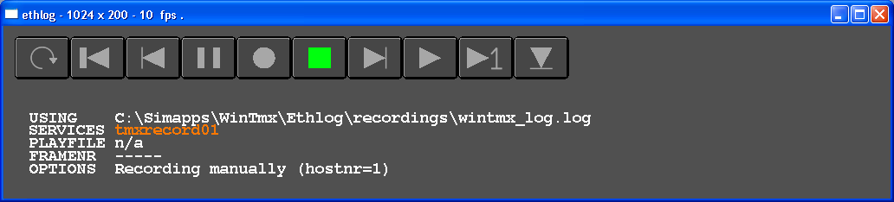
Figure 5: ETHLOG user interface

To use the ETHLOG functionality, TMX had to be extended with a new Ethernet service to send basic aircraft parameters. This service is called “tmxrecord” and uses the corresponding BSE file (see Ethernet user manual). This service is also being used to receive playback data back from the logger utility. The message can store data for up to 10 aircraft (see appendix). Waypoint information is included in order to regenerate the route.

To use the logging functionality the user needs to do the following:

- Add to the Windows services file, the new Ethernet service TMXRECORD

- Add the environment variable ETHLOGDIR and point to a directory where the files will be recorded.

- Add the environment variable ETHPATCHDIR and point to the directory where the BSE files are located, this could be: C:\WinTmx\Ethpatch\NASA\SLDAST

- Start the ETHLOG utility (shortcut RECORD_ethlog_WinTMX.bat). The recorder works like a tape-deck. Be aware that when you hit the record button it will start in Pause so you have to turn off Pause!

- Turn on ETHON in the WinTMX .\data\config.dat file (set flag to T)

- Add in the scenario the command "ETHERNET SWREC ON" or type it in when you start a scenario. Close TMX when done.

- To playback the recording, select the other shortcut: PLAY_ethlog_WinTMX.bat

- Select the far right button to select the recording you want to play

- In TMX you need to create a Playback scenario, which is the original scenario without all aircraft. NOTE: the scenario needs to be in HOLD mode and all logging commands need to be removed.

- Start the playback scenario (which has to include the command "ETHERNET SWPLAY ON") and start the ETHLOG playback. The aircraft should now be visible in TMX

While this is a working implementation of the record and playback functionality, it does come with some shortcomings:

- It requires UDP/IP - Ethernet to log and playback data, which means that its use is limited to dedicated networks (Note: do not use UDP/IP on LaRCNET !)
- The data is recorded in a separate file which means an additional large logging file next to the data file that is already being logged for path and fuel efficiency analysis.
- As the logger is a stand-alone application, there is no time synchronization between the logger and TMX. When in playback mode TMX needs to be in HOLD mode as it can not proceed time. This means TMX will not execute the internal models (ADS-B etc) as if it was in OPERATE.

A different implementation on the record and playback functionality is through the use of data that TMX collects for path and fuel efficiency analysis (see data logging manual). This playback functionality does not use any external applications and can be started by typing the following TMX command:

PLAYBACK OPEN

This will open a selection window (see Figure 6) in which the user can select the log-file that he/she wants to use. The log-file should be a comma delimited (CSV) file.

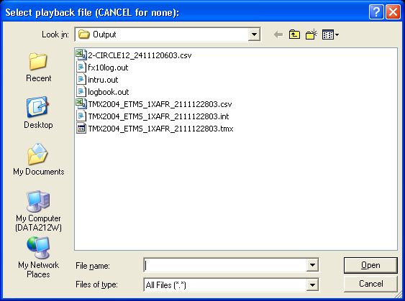
Figure 6: Select playback file
In order to use the log-file the user has to remove the first two lines (header information). If the user fails to remove the lines TMX will indicate an Error message (see Figure 7) and prompt the user to remove the lines.

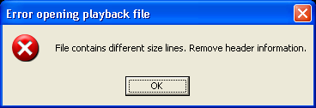
Figure 7: Error opening playback file
TMX will indicate that the file is successfully opened and a red REPLAY indicator will blink to show that TMX is now in playback mode. While in playback mode, TMX acts no different than in normal mode. Control commands like OP, HOLD, FF (Fast Forward) are still in use to control the scenario. Since there is no distinction with normal mode, scenarios can be loaded and will be executed in accordance with the timeframe. The only difference is that the position of the aircraft from the log-file will not be updated by the TMX dynamics routines but merely “moved/extrapolated”. Sensors and ASAS routines will function as before and provide the information required by the selection routines.

To skip to a specific position in the log-file, forwards or backwards, the user can use the following command:

SKIP hh:mm:ss

hh = hours
mm = minutes
ss = seconds

It is possible to stop the playback at any time and return the dynamics update of all aircraft back to TMX. This way the impact of modifications to the code can immediately be tested on the situation at hand. Stopping playback will close the file and require a new OPEN command to return to playback mode. To stop playback use the following command:

PLAYBACK OFF

With the record and playback functionality researches will be able to step through the data as they wish and use all available means (both NAV and surveillance display) to analyze any situation of interest.

External interfaces
The first paragraph gives an overview of the Ethernet connections to and from the Traffic Manager that are used to connect to other simulation programs. Connections can be made with desktop simulators but also with real-time motion based simulators.
The second paragraph explains the command string formats. The command string enables a flexible method for exchanging simulation control commands and related data.

Ethernet connections

The following diagram shows the Ethernet connections to and from the Traffic Manager. It is possible to connect more than one external simulator. To set up more than one connection the Ethernet services are postfixed with a different number for each simulator. This number is indicated in the diagram with “XX”.

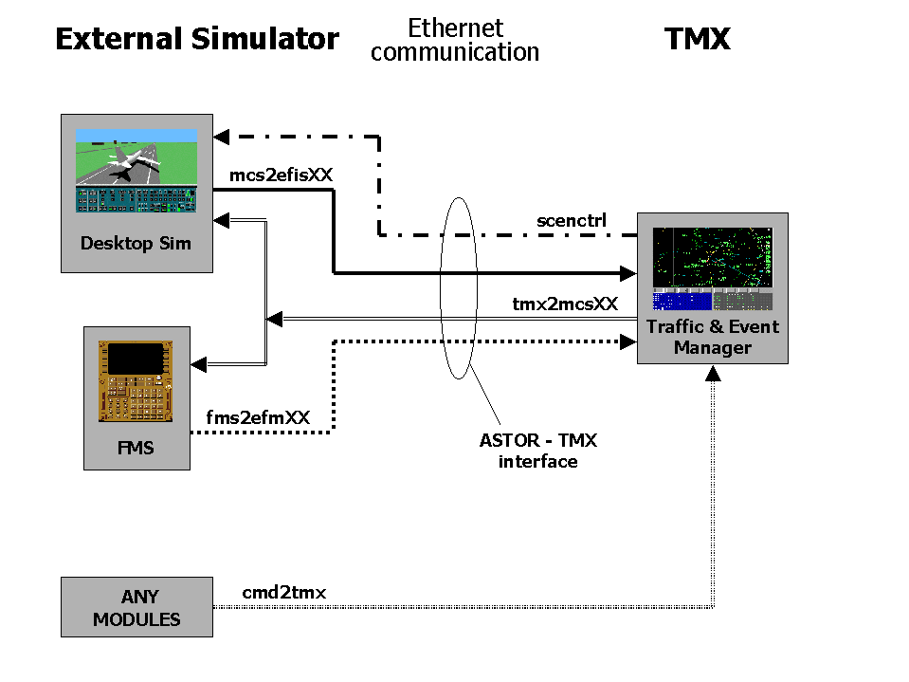

The next diagram shows how data is exchanged between the different modules within the Traffic Manager and an external simulator.

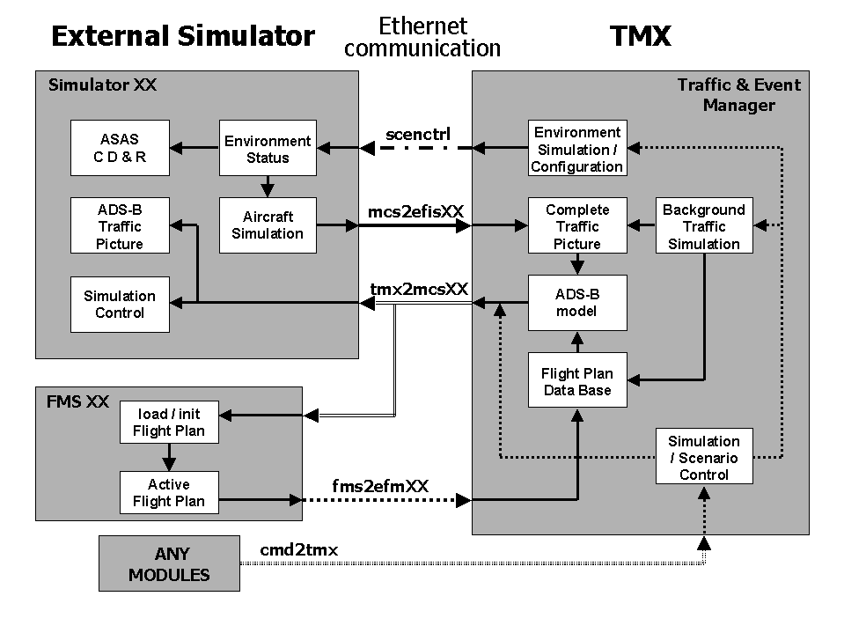
Each of the next diagrams shows one of the five Ethernet connections and lists the general data that is transmitted over that connection. A table lists the specific variables contained in the Ethernet buffers. See the following table for the definition of the variable types.

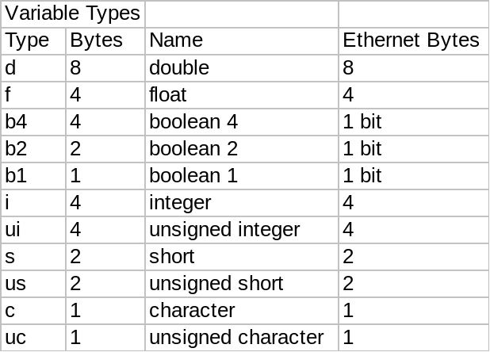
External simulator data to Traffic Manager.

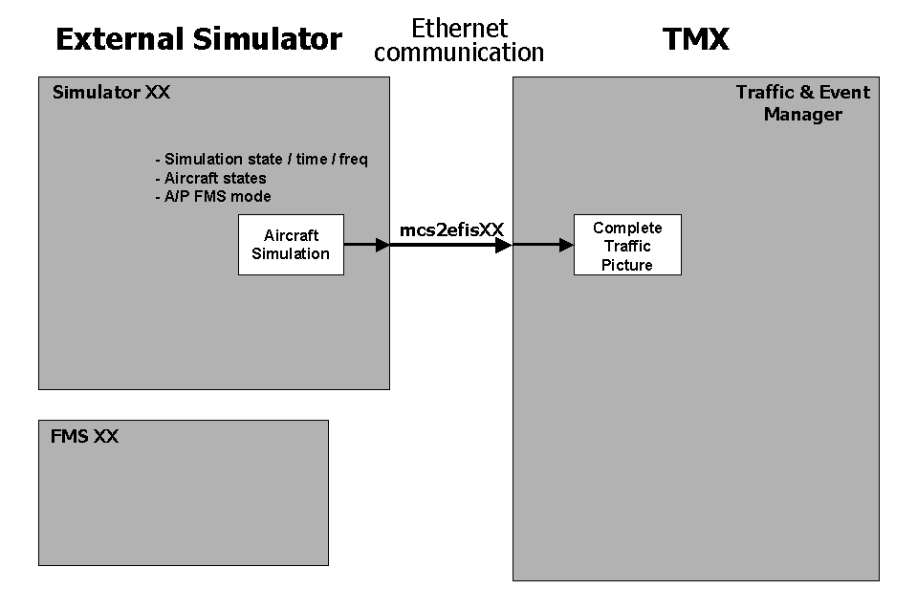
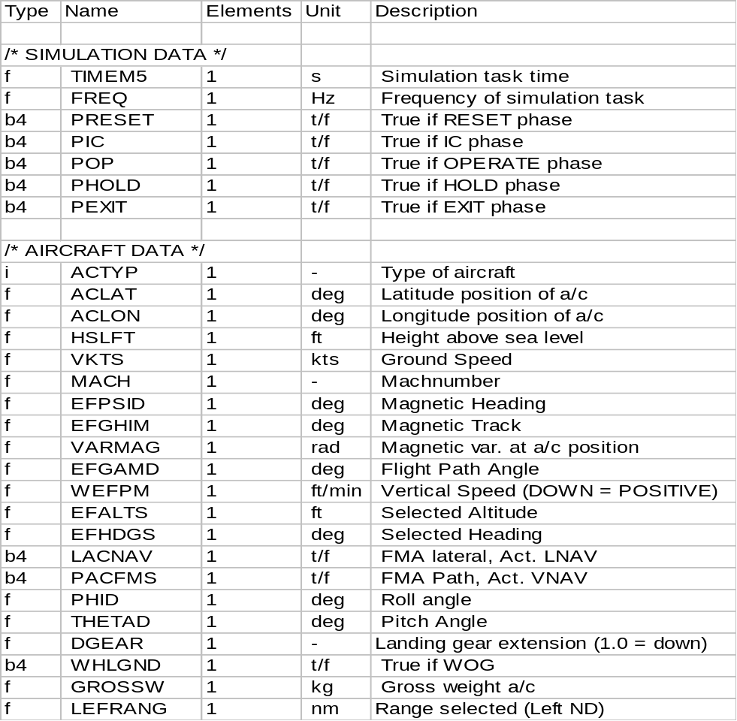

External FMS data to Traffic Manager.
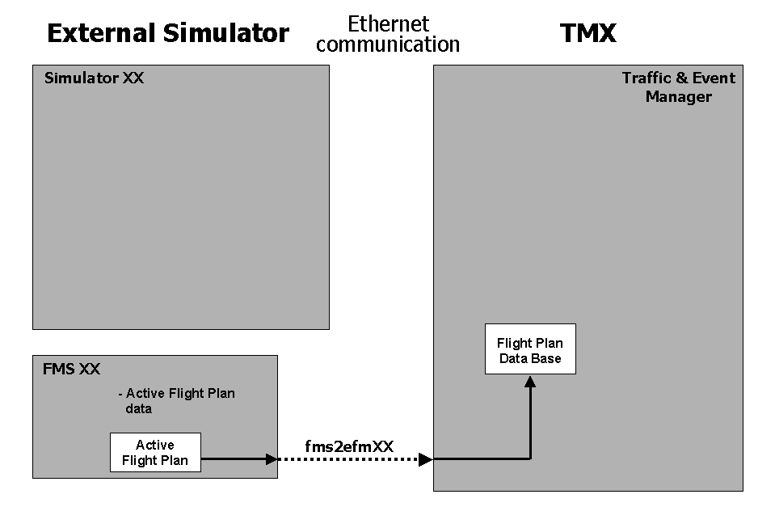
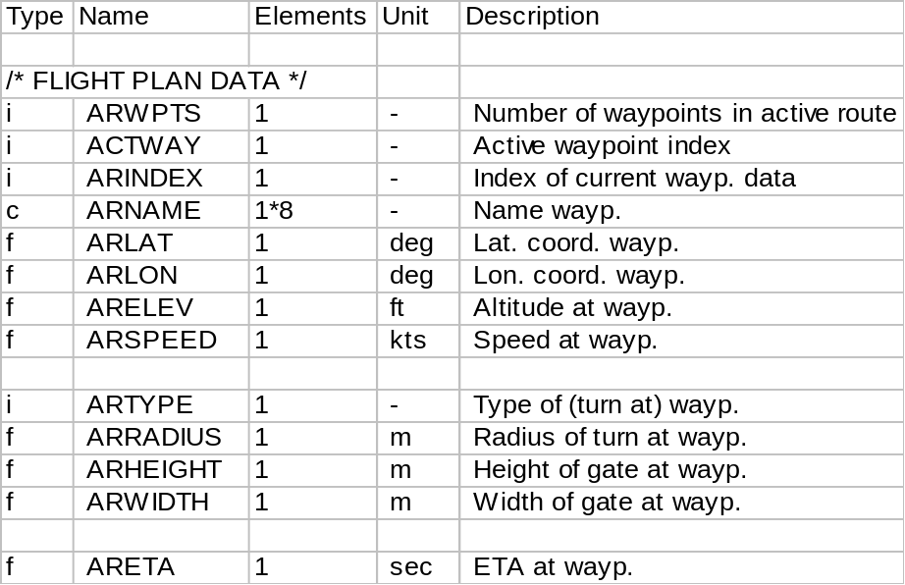
Traffic Manager data to external simulator and FMS.
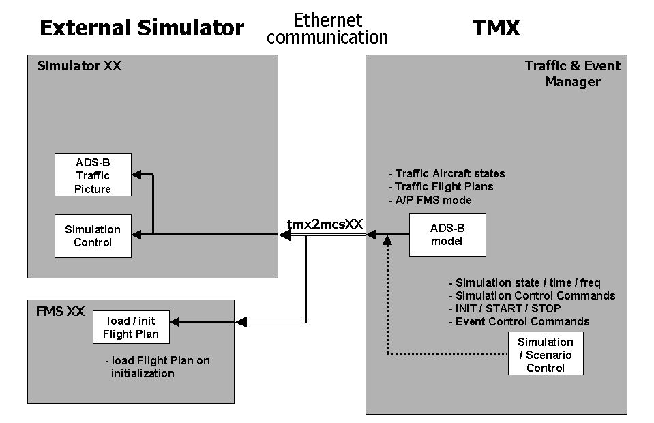
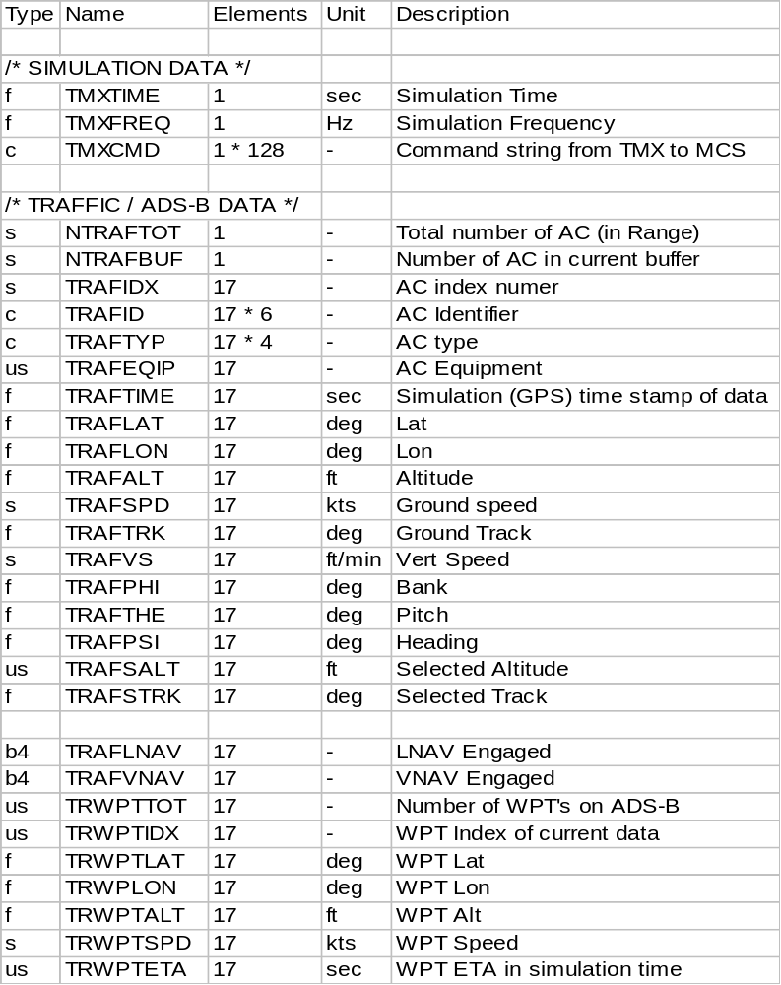
Traffic Manager data for scenario control and environment definition.
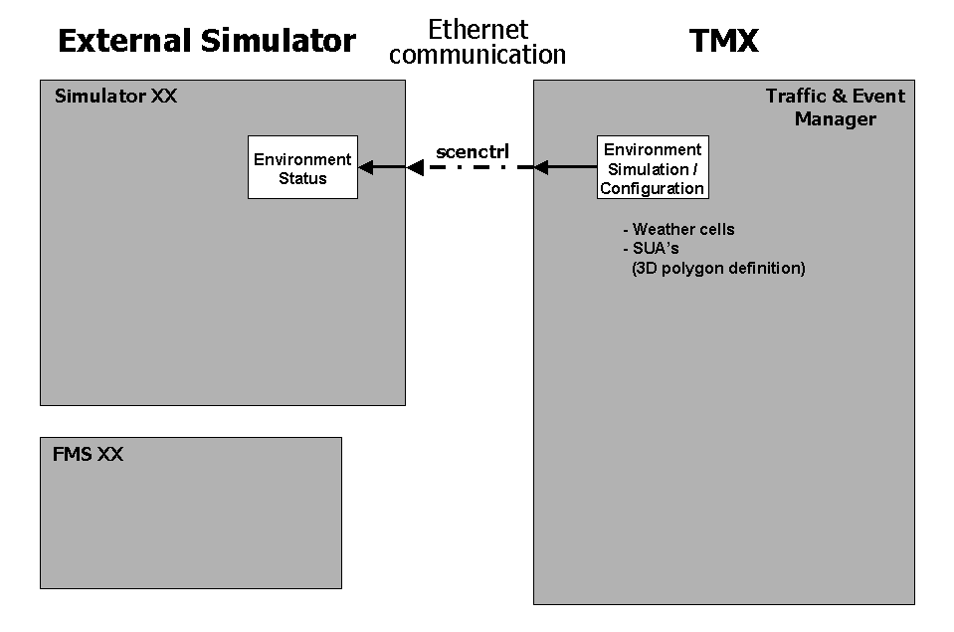

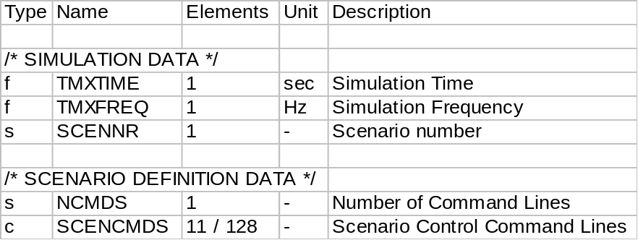
External commands from any module or program for the Traffic Manager command stack.
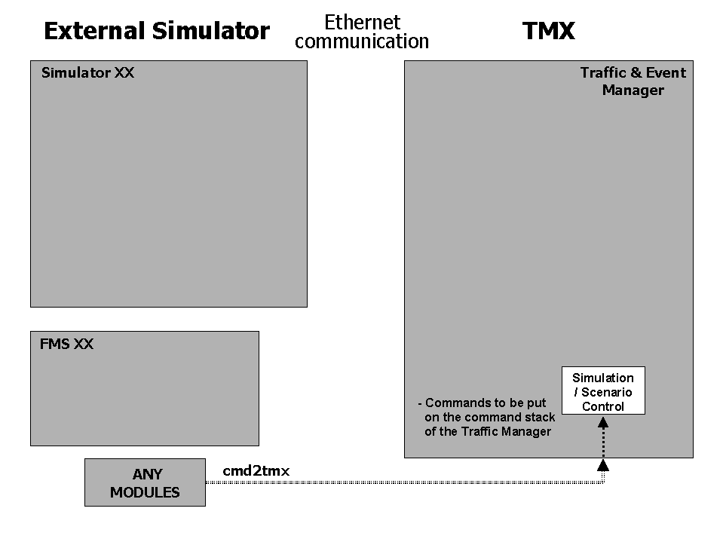
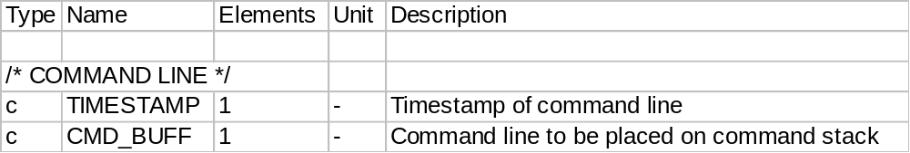

Command string formats

The command strings are used to transfer commands and related data to different applications via ethernet connections. The general format starts with a time-stamp of 8 digits containing 2 digits for hours, 2 digits for minutes, 2 digits for seconds and 2 digits for 1/100 of a second. The time-stamp is followed by a command keyword. If the command has no arguments or related data, the rest of the string is empty. Commands that use arguments are followed by these arguments in a specific format of numbers and/or text strings. These specific formats are described in this document.
The command string mechanism is used in the Traffic Manager to external simulator connections (TMX2MCSxx) for direct messaging between the Traffic Manager and one external simulator. It is also used for broadcasting Scenario Control commands via the SCENCTRL ethernet service.

This table shows the format specifier definitions that are used in the following command string formats.

Format
Specifier
Format  Specifier | Example | Description
7x |  | Empty field 7 long (just x is 1 space)
a6 | KL6012 | AscII field 6 long
i3 | _24 | Integer number, max 3 long
i5.3 | __012 | Integer number, max 5 long, minimum of 3 digits (leading zeros)
f10.2 | ____405.23 | Real number, max 10 long including decimal point, 2 decimal digits

Traffic Manager direct commands to external simulator

Command strings for handing off aircraft to external simulator

 | Timestamp | Command |  | Arguments
################### |  | GIVE Control back to TMX
 | 15454087 | GIVE
Unit
Field length | 8 | 4
Format | HHMMSShh | a4
################### |  | TAKE Control over TMX aircraft
 | 15454087 | TAKE | ID | Lat | Lon | Alt | Speed | Course | Vert.Spd
Unit |  |  |  | deg | deg | ft | kts | deg | ft/sec
Field length | 8 | 4 | 9 | 13 | 13 | 6 | 6 | 6 | 6
Format | HHMMSShh | a4 | x,a8 | f13.6 | f13.6 | i6 | f6.1 | f6.1 | f6.1
################### |  | RePOSition aircraft
 | 15454087 | RPOS | ID | Lat | Lon | Alt | Speed | Course | Vert.Spd
Unit |  |  |  | deg | deg | ft | kts | deg | ft/sec
Field length | 8 | 4 | 9 | 13 | 13 | 6 | 6 | 6 | 6
Format | HHMMSShh | a4 | x,a8 | f13.6 | f13.6 | i6 | f6.1 | f6.1 | f6.1

GIVE The GIVE command tells the external simulator to release control over its simulated aircraft. From that moment the aircraft will again be simulated by the Traffic Manager.

TAKE The TAKE command tells the external simulator to take control over the specified simulated aircraft at the specified location and state. The Traffic Manager will wait for the external simulator to start the aircraft simulation. On receiving valid aircraft simulation data control is transferred to the external simulator.

RPOS The RePOSition command tells the external simulator to adjust the simulated aircraft position to the specified coordinates. This is used for a position resynchronisation after a take command.

Command strings for controlling aircraft simulation at external simulator

 | Timestamp | Command |  | Arguments
################### |  | Operate command, Start simulation run
 | 15454087 | OP
Unit
Field length | 8 | 2
Format | HHMMSShh | a2
################### |  | HOLD command, Freeze simulation run
 | 15454087 | HOLD
Unit
Field length | 8 | 4
Format | HHMMSShh | a4
################### |  | IC command, Set simulation to Initial Condition
 | 15454087 | IC
Unit
Field length | 8 | 2
Format | HHMMSShh | a2
################### |  | EVEnt number
 | 15454087 | EVE* | NUM
Unit
Field length | 8 | 5 | 2
Format | HHMMSShh | a5 | i2

OP The OP command tells the external simulator to switch to the operate simulation state.

HOLD The HOLD command tells the external simulator to freeze the simulation.

IC The IC command tells the external simulator to switch to the Initial Condition phase. In this case the locally defined Initial Condition will be loaded.

EVE* The EVE* command tells the external simulator that a predefined event takes place. This event is identified by the event number that is sent as a argument with the EVE* command.

 | Timestamp | Command |  | Arguments
################### |  | TEXT, send text string to external simulator.
 | 15454087 | TEXT | String
Unit
Field length | 8 | 5 | 115
Format | HHMMSShh | a5 | a115

TEXT The TEXT is used to send over text strings to the external simulator. This can be used to simulate Data Link messages being uploaded to the external simulator.

Command strings for controlling Auto Pilot and Auto Throttle at external simulator

 | Timestamp | Command |  | Arguments
################### |  | Auto Pilot ON / OFF command
 | 15454087 | AP | ON / OFF
Unit
Field length | 8 | 4 | 3
Format | HHMMSShh | a4 | a3
################### |  | Auto Throttle ON / OFF command
 | 15454087 | AT | ON / OFF
Unit
Field length | 8 | 4 | 3
Format | HHMMSShh | a4 | a3

AP The AP command tells the external simulator to switch ON or switch OFF the Auto Pilot depending on the argument.

AT The AT command tells the external simulator to switch ON or switch OFF the Auto Throttle depending on the argument.

Command strings for uploading FMS flight plan to external simulator

 | Timestamp |  | Command |  |  | Arguments
############### |  |  | TUBE, FMS waypoints
 | 15454087 |  | TUBE |  | Index | Name | Lat | Lon | Alt | Height | Width | Type | Speed | RTA
Unit |  |  |  |  |  |  | deg | deg | ft | m | m |  | kts | sec
Field length | 8 |  | 4 |  | 3 | 9 | 11 | 11 | 8 | 8 | 8 | 3 | 7 | 7
Format | HHMMSShh |  | a4 |  | x,i2 | x,a8 | x,f10.5 | x,f10.5 | x,f7.1 | x,f7.1 | x,f7.1 | x,i2 | f7.3 | i7
Special values: |  | INDEX = -1 |  | Clear Flight Plan
 |  | INDEX = 0 |  | Alt = Cruise Alt (on PERF page)
 |  |  |  | Type = Total number of waypoints in flight plan.
 |  | INDEX > 0 |  | WPT_Name(INDEX) = Name
 |  |  |  | WPT_Lat(INDEX) = Lat

TUBE The TUBE command defines the waypoints for the flight plan of the external simulator. Typically a series of TUBE commands are send to the external simulator before the TAKE command is issued. In this way the FMS of the external simulator is preloaded with the flight plan of the aircraft it will be assigned to by the TAKE command. It may be necessary to check if all waypoints from the complete flight plan are received. If this is not the case an error message should be generated.

The altitude field specifies the altitude constrained at that waypoint. If the altitude field contains a value smaller or equal to zero, there is no altitude constrained at that waypoint. The same applies to the speed field. The RTA field specifies the required time of arrival in seconds of simulation time.

Traffic Manager scenario control messaging commands

Command strings for Scenario Control for Polygons / WX / SUA / Sector

 | Timestamp | Command | Arguments
################### |  | Define Polygon
 | 15454087 | DEFPOLY | Poly-ID | Type | Ntot | Nbuf | Index | Alt low | Alt high | Lat-1 | Lon-1 | Lat-2 | Lon-2
Unit
Field length | 8 | 8 | 8 | 5 | 3 | 3 | 3 | 8 | 9 | 8 | 9 | 8 | 9
Format | HHMMSShh | a8 | a8 | i5 | i3 | i3 | i3 | f8.2 | f9.2 | f8.4 | f9.4 | f8.4 | f9.4
################### |  | Add points to Polygon
 | 15454087 | ADDPOLY | Poly-ID | Type | Ntot | Nbuf | Index | Lat-1 | Lon-1 | Lat-2 | Lon-2 | …
Unit
Field length | 8 | 8 | 8 | 5 | 3 | 3 | 3 | 8 | 9 | 8 | 9 | …
Format | HHMMSShh | a8 | a8 | i5 | i3 | i3 | i3 | f8.4 | f9.4 | f8.4 | f9.4 | …
################### |  | Delete Polygons
 | 15454087 | DELPOLY | Ndel | ID-1 | ID-2 | … | ID-13
Unit
Field length | 8 | 8 | 3 | 8 | 8 |  | 8
Format | HHMMSShh | a8 | i2,x | a8 | a8 |  | a8

DEFPOLY The DEFPOLY command defines a polygon, new or existing. Each polygon is identified by its maximum 8 character ID. The type of polygon is expressed in a type number that can be decoded from the table below.
Ntot is the total number of Lat/Lon pairs in the polygon.
Nbuf is the number of Lat/Lon pairs in this command string.
Index is the index number of the first Lat/Lon pair in this command string, for DEFPOLY this is always 1.
DEFPOLY data starts with a low/high altitude pair, and then continues with the Lat/Lon pairs. There is space for a maximum

ADDPOLY The ADDPOLY command complements the DEFPOLY command by supplying additional polygon points. The format is almost the same as the DEFPOLY format. The only difference is that ADDPOLY doesn’t contain the low/high altitude pair, but only contains Lat/Lon pairs.

DELPOLY The DELPOLY command is used to remove polygon definitions for the polygon data base. Ndel defines the number of Poly-ID’s that are contained in the command string. The DELPOLY command is repeated several times for each Poly-ID. This is to overcome possible message losses.

This table shows the different polygon types with there values. Note that these types can be combined by adding up their individual values.

Type | Value
General | 0
WX / Weather | 1
SUA |  | 2
Sector |  |  | 4

Appendix I: Example scenario files
Scenario file: TFM_test101.scn

## TFM test scenario 101

# Center on LFPG
PAN LFPG
---

# Set UTC time
time utc 0

# Flights between EHAM / EBBR / EGLL / LFPG / EDDF / EIDW / LIRF
CF KLM001 F100 EHAM EGLL 3600
CF KLM002 F100 EGLL EHAM 3600
CF KLM003 F100 EHAM EDDF 3600
CF KLM004 F100 EDDF EHAM 3600
CF KLM005 F100 EHAM EBBR 3600
CF KLM006 F100 EBBR EHAM 3600
CF KLM007 F100 EHAM LFPG 3600
CF KLM008 F100 LFPG EHAM 3600
CF KLM009 F100 EHAM EIDW 3600
CF KLM010 F100 EIDW EHAM 3600

CF DLH001 B737 EDDF EGLL 3600
CF DLH002 B737 EGLL EDDF 3600
CF DLH003 B737 EDDF EHAM 3600
CF DLH004 B737 EHAM EDDF 3600
CF DLH005 B737 EDDF EBBR 3600
CF DLH006 B737 EBBR EDDF 3600
CF DLH007 B737 EDDF LFPG 3600
CF DLH008 B737 LFPG EDDF 3600
CF DLH009 B737 EDDF EIDW 3600
CF DLH010 B737 EIDW EDDF 3600

CF AFR001 CRJ7 LFPG EGLL 3600
CF AFR002 CRJ7 EGLL LFPG 3600
CF AFR003 CRJ7 LFPG EHAM 3600
CF AFR004 CRJ7 EHAM LFPG 3600
CF AFR005 CRJ7 LFPG EBBR 3600
CF AFR006 CRJ7 EBBR LFPG 3600
CF AFR007 CRJ7 LFPG EDDF 3600
CF AFR008 CRJ7 EDDF LFPG 3600
CF AFR009 CRJ7 LFPG EIDW 3600
CF AFR010 CRJ7 EIDW LFPG 3600

CF BAW001 A320 EGLL LFPG 3600
CF BAW002 A320 LFPG EGLL 3600
CF BAW003 A320 EGLL EHAM 3600
CF BAW004 A320 EHAM EGLL 3600
CF BAW005 A320 EGLL EBBR 3600
CF BAW006 A320 EBBR EGLL 3600
CF BAW007 A320 EGLL EDDF 3600
CF BAW008 A320 EDDF EGLL 3600
CF BAW009 A320 EGLL EIDW 3600
CF BAW010 A320 EIDW EGLL 3600

CF AZA001 MD83 LIRF LFPG 3600
CF AZA002 MD83 LFPG LIRF 3600
CF AZA003 MD83 LIRF EHAM 3600
CF AZA004 MD83 EHAM LIRF 3600
CF AZA005 MD83 LIRF EBBR 3600
CF AZA006 MD83 EBBR LIRF 3600
CF AZA007 MD83 LIRF EDDF 3600
CF AZA008 MD83 EDDF LIRF 3600
CF AZA009 MD83 LIRF EIDW 3600
CF AZA010 MD83 EIDW LIRF 3600

# Execute the TFM scheduling
TFM SCHEDULE
Scenario file: TFM_test102.scn

## TFM test scenario 102

# Center on KEWK
PAN KEWK
----

# Set UTC time
TIME UTC 1:00:00

# Set Airport filter parameters to limit number of flights read from traffic sample file
LOADFLIGHTS FILTER MASK K
LOADFLIGHTS FILTER RWYLEN 9500

# Load Flights from traffic sample file
LOADFLIGHTS TSAM1.CSV

# Execute the TFM scheduling
TFM SCHEDULE

Scenario file: TFM_test103.scn

## TFM test scenario 103

# Center on KEWK
PAN KEWK
----

# Switch off label to declutter radar screen
label 0
wptlabel 0
symbol 5
wptsymbol off

# Set UTC time
TIME UTC 1:00:00

# Load Flights from traffic sample file
LOADFLIGHTS TSAM1.CSV

# Execute the TFM scheduling
TFM SCHEDULE

